

**LAB FILE**

**Web Programming with Python and JavaScript Lab**

**(SEC 035)**

**SUBMITTED BY:**

**ADEELA AZEEZ**

**SUBMIITED TO:**

**DR. TANVI CHAWLA**

**ROLL NUMBER: 2301010282**

**COURSE: BTECH CSE CORE**

**SECTION: E**

**School of Engineering & Technology**

**K. R. MANGALAM UNIVERSITY**

**Sohna, Haryana 122103, India**

**INDEX**

|  |  |  |  |
| --- | --- | --- | --- |
| **S.NO** | **DATE** | **TITLE** | **PG.NO** |
| 1. | 30 January 2025 | Experiment 1: Restaurant Project | 3-8 |
| 2. | 06 February 2025 | Experiment 2: JavaScript Basics | 9-25 |
| 3. | 13 February 2025 | Experiment 3: Calculator, To-Do List, Registration Form | 26-35 |
| 4. | 17 February 2025 | Experiment 4: Portfolio | 36-39 |
| 5. | 23 February 2025 | Experiment 5: Rock Paper Scissor, Movies and Books Library, Weather Portal | 40-51 |
| 6. | 27 February 2025 | Experiment 6: Quotes Generator, List Manager | 52-53 |
| 7. | 03 March 2025 | Experiment 7: Pattern Printing | 54-57 |
| 8. | 17 March 2025 | Experiment 8: E Commerce Website | 58-62 |
| 9. | 20 March 2025 | Experiment 9: DOM Implementation | 63-72 |
| 10. | 27 March 2025 | Experiment 10: Basics of Python | 73-81 |
| 11. | 03 April 2025 | Experiment 11: Basic Flask Programs | 82-84 |
| 12. | 07 April 2025 | Experiment 12: Rendering HTML pages using Flask | 85-89 |

**EXPERIMENT 1**

***Experiment 1: Create a frontpage for a restaurant website using HTML, CSS.***

**CODE:**

**HTML:**

<!DOCTYPE html>

<html lang>

<head>

    <title>Restaurant</title>

    <link rel="stylesheet" href="firstpage.css">

</head>

<body>

    <fieldset id="first">

        <section>

            <h1 id="mainh">THE FAMILY RESTAURANT</h1>

            <img src="firstimg.jpg" alt="Firstimg" height="400" width=100%>

            <section id="list">

                <ul>

                    <li><a href="#Aboutus">About us</a></li>

                    <li><a href="#vegmenu">Veg Menu</a></li>

                    <li><a href="#desserts">Desserts</a></li>

                </ul>

            </section>

        </section>

        </fieldset>

        <br><br><br>

        <fieldset id="second">

        <section id="Aboutus">

            <h2 id="sh"> About us</h2>

            <p>Welcome to <b>Crafted Bites,</b> where passion for food meets a love for hospitality. Nestled in the

heart of Mumbai, India, we take pride in offering a dining experience that blends fresh, locally sourced

ingredients with flavors inspired by vegetarian cuisine and indulgent desserts.<br>At <b>Crafted Bites,</b>

every dish is carefully curated, from our wholesome vegetarian specialties to our handcrafted desserts and

refreshing beverages. Whether you're here for a casual meal, a special celebration, or just to unwind with

good company, our warm and inviting atmosphere makes every visit memorable.<br>Our commitment to

quality, exceptional service, and a welcoming ambiance ensures that every guest leaves satisfied and eager

to return. Come join us and experience the perfect fusion of great food, great people, and great

moments.<br>We can’t wait to serve you!.</p>

        </section>

    </fieldset>

    <br><br><br>

    <fieldset id="third">

        <section id="vegmenu">

            <h2 id="sh">Veg Menu</h2>

            <table id="table1" border="1">

                <thead>

                    <th>S.No</th>

                    <th>Dish</th>

                    <th>Price</th>

                    <th>Picture</th>

                    <th>Recepie</th>

                </thead>

                <tbody>

                    <tr>

                        <td>1.</td>

                        <td>Paneer Makhmali Tikka</td>

                        <td>200</td>

                        <td><img src="veg1.jpg" alt="veg1" height="255" width="198"></td>

                        <td><a href="https://www.tarladalal.com/makhmali-paneer-tikka-made-in-oven-tawa-

32713r">Recepie</a></td>

                    </tr>

                    <tr>

                        <td>2.</td>

                        <td>Stuff Achari Mushroom</td>

                        <td>300</td>

                        <td><img src="veg2.jpg" alt="veg2" height="255" width="198"></td>

                        <td><a href="https://cookpad.com/in/recipes/16816927-achari-ricotta-stuffed-

mushrooms">Recepie</a></td>

                    </tr>

                    <tr>

                        <td>3.</td>

                        <td>Veg Roll with Sweet Chilli Dip</td>

                        <td>250</td>

                        <td><img src="veg3.jpg" alt="vg3" height="255" width="198"></td>

                        <td><a href="https://loveisinmytummy.com/2015/09/spring-rolls-with-sweet-chilli-

dipping.html">Recepie</a></td>

                    </tr>

                    <tr>

                        <td>4.</td>

                        <td>Palak Patey & Chat</td>

                        <td>350</td>

                        <td><img src="veg4.jpg" alt="veg4" height="255" width="198"></td>

                        <td><a href="https://www.chefajaychopra.com/food-recipes/palak-patta-chaat-

recipe">Recepie</a></td>

                    </tr>

                    <tr>

                        <td>5.</td>

                        <td>Cheese Slider with Sriracha Aioli</td>

                        <td>300</td>

                        <td><img src="vwg5.jpg" alt="veg5" height="255" width="198"></td>

                        <td><a href="https://entirelyelizabeth.com/cheesy-ground-beef-sliders/">Recepie</a></td>

                    </tr>

                </tbody>

            </table>

        </section>

    </fieldset>

    <br><br><br>

    <fieldset id="fourth">

        <section id="desserts">

            <h2 id="sh">Desserts</h2>

            <table id="table2" border="1">

                <thead>

                    <th>S.No</th>

                    <th>Dish</th>

                    <th>Price</th>

                    <th>Picture</th>

                    <th>Recepie</th>

                </thead>

                <tr>

                    <td>1.</td>

                    <td>Kesri Gulab Jamun</td>

                    <td>60</td>

                    <td><img src="desserts1.jpg" alt="des" height="225" width="225"></td>

                    <td><a href="https://www.kesarisaffron.com/gulab-jamun-recipe-with-khoya/">Recepie</a></td>

                </tr>

                <tr>

                    <td>2.</td>

                    <td>Moong Dal Halwa</td>

                    <td>70</td>

                    <td><img src="dessert2.jpg" alt="des2" height="225" width="225"></td>

                    <td><a href="https://www.indianhealthyrecipes.com/moong-dal-halwa/">Recepie</a></td>

                </tr>

                <tr>

                    <td>3.</td>

                    <td>Rasgulla</td>

                    <td>40</td>

                    <td><img src="dessert3.jpg" alt="des3" height="225" width="225"></td>

                    <td><a href="https://www.indianhealthyrecipes.com/rasgulla-recipe-bengali-rasgulla-recipe-easy-diwali-

sweet-recipe/">Recepie</a></td>

                </tr>

                <tr>

                    <td>4.</td>

                    <td>Gajar Ka Halwa</td>

                    <td>80</td>

                    <td><img src="dessert4.jpg" alt="des4" height="225" width="225"></td>

                    <td><a href="https://www.indianhealthyrecipes.com/carrot-halwa-recipe-gajar-ka-halwa-

recipe/">Recepie</a></td>

                </tr>

                <tr>

                    <td>5.</td>

                    <td>Chocolate Brownie</td>

                    <td>50</td>

                    <td><img src="dessert5.jpg" alt="des5" height="225" width="225"></td>

                    <td><a href="https://www.loveandlemons.com/brownies-recipe/">Recepie</a></td>

                </tr>

            </table>

        </section>

    </fieldset>

</body>

</html>

**CSS:**

 body{

            background-image: url("BGIMAGE.jpg");

            background-color: #a87a48;

        }

        #mainh{

            font-family: 'Times New Roman', Times, serif;

            border-collapse:separate;

            text-align: center;

        }

        #sh{

            font-size:xx-large;

        }

        #list{

            font-size:large;

        }

        #table1{

            font-family: Arial, Helvetica, sans-serif;

            border-collapse: collapse;

            width: 100%;

        }

        #table1 td{

            text-align: center;

            font-size: x-large;

        }

        #table1 th{

            text-align: center;

            color: rgb(10, 10, 10);

            font-size: xx-large;

        }

        #table2{

            font-family: Arial, Helvetica, sans-serif;

            border-collapse: collapse;

            width: 100%;

        }

        #table2 td{

            text-align: center;

            font-size:x-large;

        }

        #table2 th{

            text-align: center;

            color: rgb(3, 3, 3);

            font-size: xx-large;

        }

**OUTPUT:**

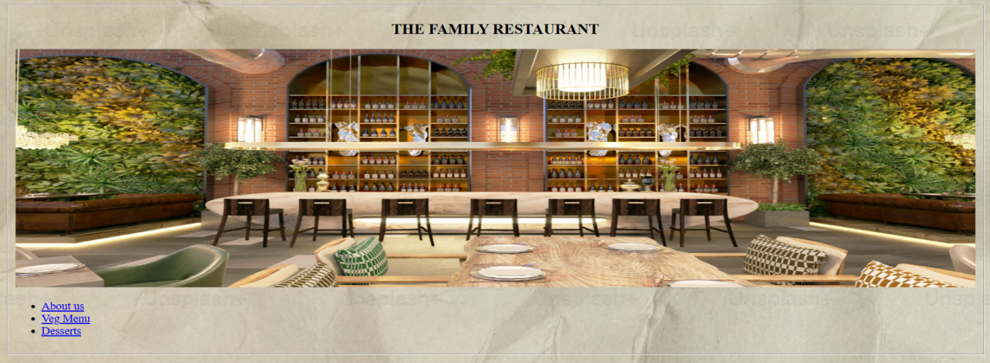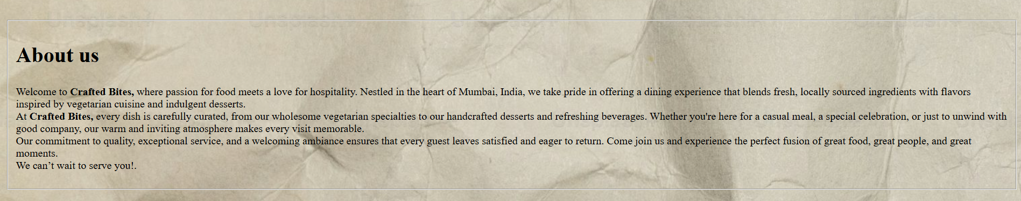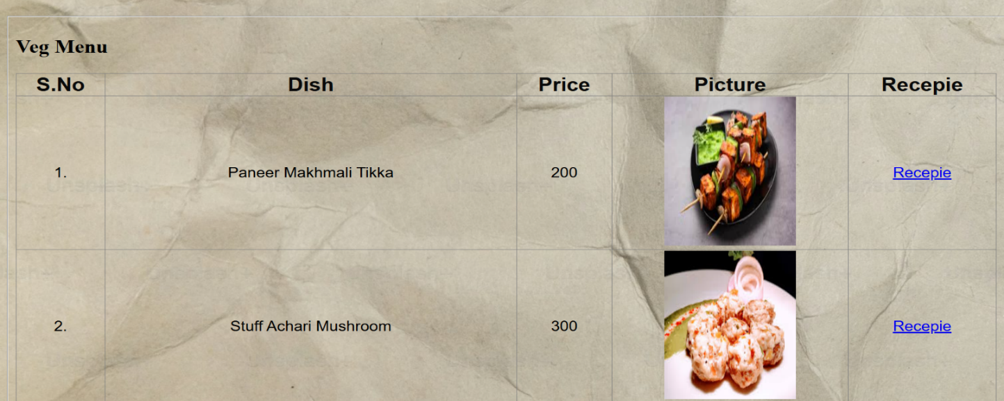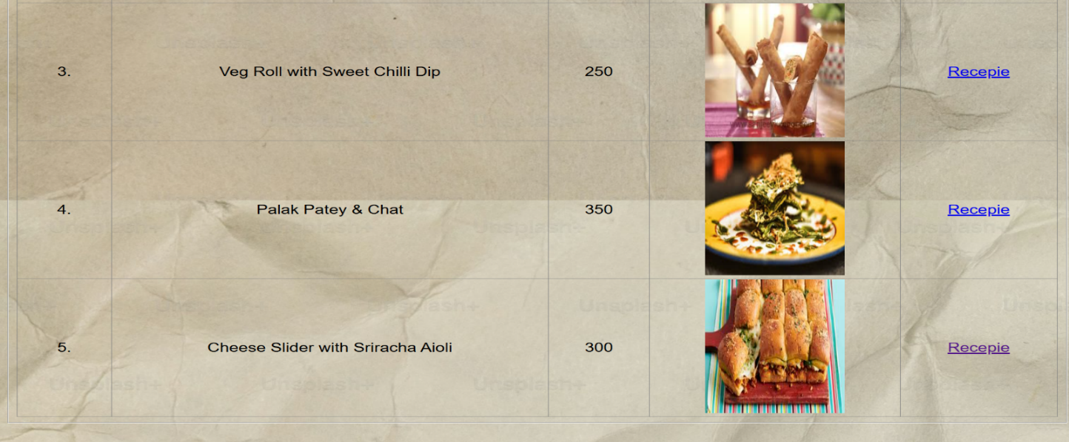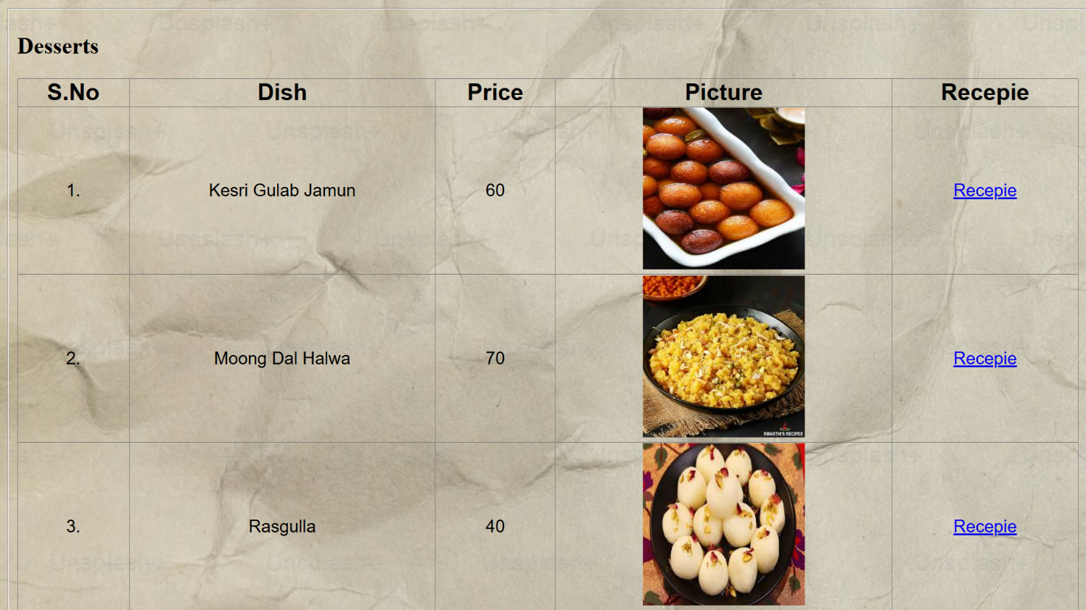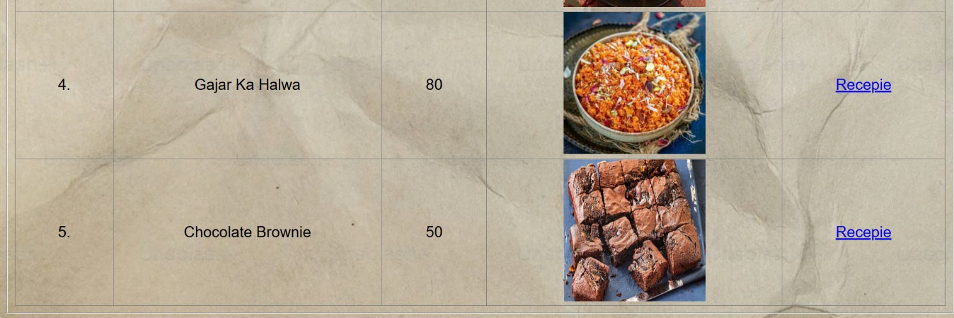

**EXPERIMENT 2.1**

**JAVASCRIPT BASIC PROGRAMS**

***Experiment 2.1.1: Odd and Even Number:***

**Code:**

function checkEvenOdd(number)

{

    if(number%2==0)

    {

        return "Even";

    }

    else{

        return "Odd";

    }

}

console.log(checkEvenOdd(7));

console.log(checkEvenOdd(10));

**Output:**

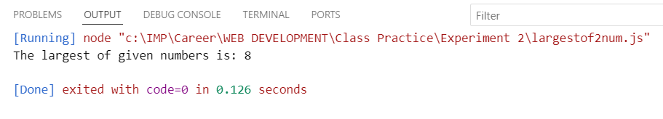

***Experiment 2.1.2: Factorial of a Number:***

**Code:**

function findFactorial(number)

{

    let fact=1;

    for(let i=1; i<=number; i++)

    {

        fact=fact*i;

    }

    return fact;

}

console.log(findFactorial(5));

console.log(findFactorial(6));

**Output:**

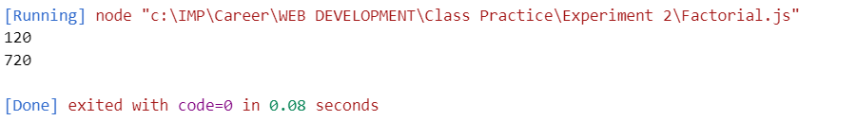

***Experiment 2.1.3: Prime Number:***

**Code:**

let n = 17;

let isPrime = true;

if (n <= 1) {

    isPrime = false;

} else {

    for (let i = 2; i * i <= n; i++) {

        if (n % i === 0) {

            isPrime = false;

            break;

        }

    }

}

console.log(isPrime ? `${n} is a prime number.` : `${n} is not a prime number.`);

**Output:**

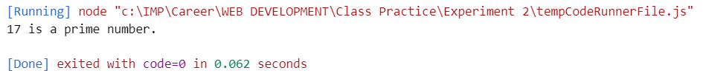

***Experiment 2.1.4: Largest of two numbers:***

**Code:**

function largest(a,b){

    if(a>b){

        return a;

    }

    else{

        return b;

    }

}

console.log(`The largest of given numbers is: `+largest(8,2))

**Output:**

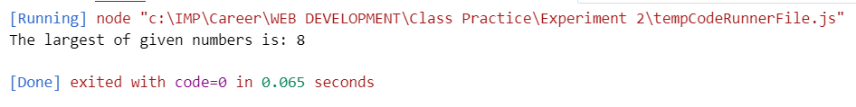

***Experiment 2.1.5: Sum of given array:***

**Code:**

const arr = [23, 34, 77, 99, 34];

let sum = 0;

for (let i = 0; i < arr.length; i++) {

sum += arr[i];

}

console.log(sum);

**Output:**

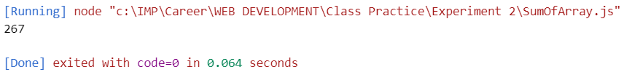

***Experiment 2.1.6: Swapping two numbers:***

**Code:**

let t;

let num1=20;

let num2=30;

console.log(`before swap num1= ${num1}`);

console.log(`before swap num2= ${num2}`);

t=num1;

num1=num2;

num2=t;

console.log(`after swap a= ${num1}`);

console.log(`after swap a= ${num2}`);

**Output:**

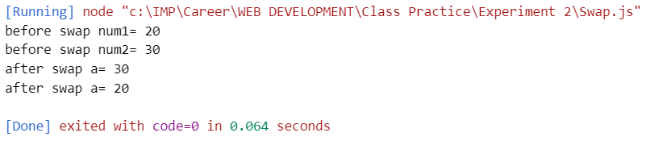

***Experiment 2.1.7: Table of a Number:***

**Code:**

function table(number)

{

    for (let i=1;i<=10; i++)

        {

            var result=i*number;

            console.log(`${number}*${i}=${result}`);

        } }

table(6);

**Output:**

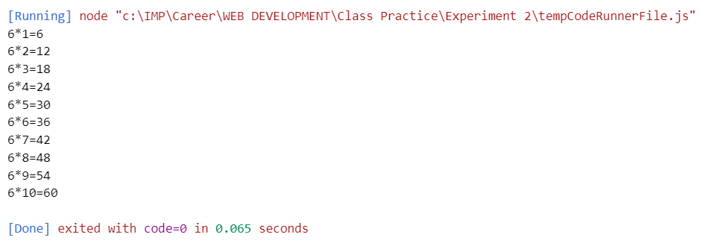

**EXPERIMENT 2.2**

**JAVASCRIPT OUTPUT PROGRAMS**

***Experiment 2.2.1: Using innerHTML:***

**Code:**

<!DOCTYPE html>

<html>

<body>

<h2>My First Web Page</h2>

<p>My First Paragraph.</p>

<p id="demo"></p>

<script>

document.getElementById("demo").innerHTML = 5 + 6;

</script>

</body>

</html>

**Output:**

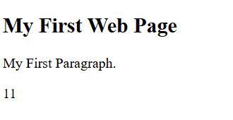

***Experiment 2.2.2: Using document.write()***

**Code:**

<!DOCTYPE html>

<html>

<body>

<h2>My First Web Page</h2>

<p>My first paragraph.</p>

<p>Never call document.write after the document has finished loading.

It will overwrite the whole document.</p>

<script>

document.write(5 + 6);

</script>

</body>

</html>

**Output:**

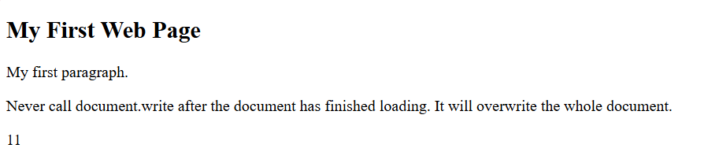

***Experiment 2.2.3: Using document.write() using Try it***

**Code:**

<!DOCTYPE html>

<html>

<body>

<h2>My First Web Page</h2>

<p>My first paragraph.</p>

<button type="button" onclick="document.write(5 + 6)">Try it</button>

</body>

</html>

**Output:**

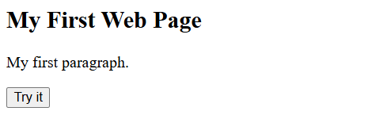

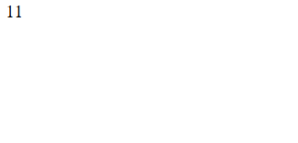

***Experiment 2.2.4: Using window.alert()***

**Code:**

<!DOCTYPE html>

<html>

<body>

<h1>My First Web Page</h1>

<p>My first paragraph.</p>

<script>

window.alert(5 + 6);

</script>

</body>

</html>

**Output:**

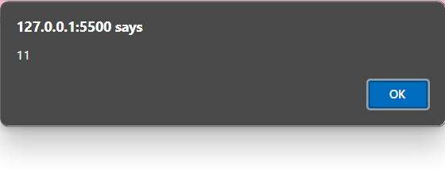

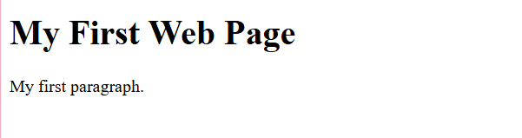

***Experiment 2.2.5: Using alert()***

**Code:**

<!DOCTYPE html>

<html>

<body>

<h1>My First Web Page</h1>

<p>My first paragraph.</p>

<script>

window.alert(5 + 6);

</script>

</body>

</html>

**Output:**





***Experiment 2.2.6: Using console.log()***

**Code:**

<html>

<head></head>

<body>

    <h1>Check the console for the message!</h1>

    <script>

        console.log("Hello, World!");

    </script>

</body>

</html>

**Output:**

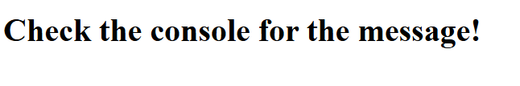

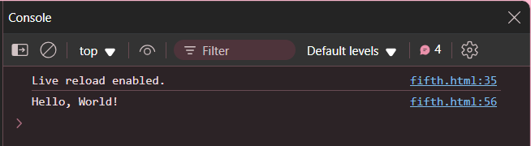

***Experiment 2.2.7: Using windows.print()***

**Code:**

<!DOCTYPE html>

<html>

<body>

<button onclick="window.print()">Print this page</button>

</body>

</html>

**Output:**

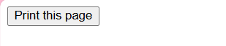

***Experiment 2.2.8: External JavaScript***

**Code:**

**HTML:**

<!DOCTYPE html>

<html>

<body>

<h2>Demo External JavaScript</h2>

<p id="demo">A Paragraph.</p>

<button type="button" onclick="myFunction()">Try it</button>

<p>This example links to "myScript.js".</p>

<p>(myFunction is stored in "myScript.js")</p>

<script src="seventh.js"></script>

</body>

</html>

**JAVASCRIPT**

function myFunction() {

document.getElementById("demo").innerHTML = "Paragraph changed.";

}

**Output:**

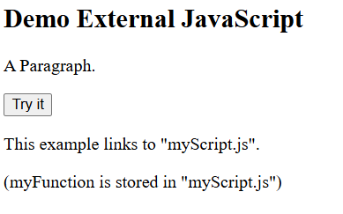 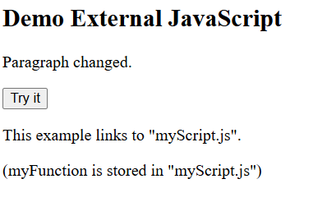

***Experiment 2.2.9: Displaying hidden HTML elements using JavaScript***

**Code:**

<!DOCTYPE html>

<html>

<body>

<h2>What Can JavaScript Do?</h2>

<p>JavaScript can show hidden HTML elements.</p>

<p id="demo" style="display:none">Hello JavaScript!</p>

<button type="button" onclick="document.getElementById('demo').style.display='block'">Click Me!</button>

</body>

</html>

**Output:**

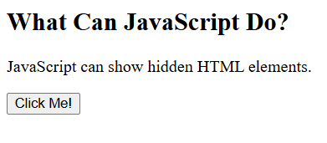  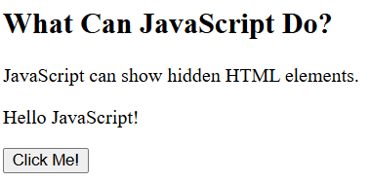

***Experiment 2.2.10: Printing an array***

**Code:**

**HTML and CSS:**

<!DOCTYPE html>

<html lang="en">

<head>

    <meta charset="UTF-8">

    <meta name="viewport" content="width=device-width, initial-scale=1.0">

    <title>Document</title>

    <style>

        body{

            padding:20px;

        }

        .container{

            height: 200px;

            width: 300px;

            padding: 5px;

            border: solid black 2px;

            background-color: aquamarine;

        }

        p{

            font-size: 30px;

        }

        button{

            font-size:20px;

            padding: 5px;

            font-family: 'Times New Roman', Times, serif;

        }

    </style>

    <script src="tenth.js"></script>

</head>

<body>

    <div class="container">

        <button type="button" onclick="myFunction()">Click to print array</button>

    <p id="demo"></p>

        </div>

</body>

</html>

**JavaScript:**

function myFunction() {

let numbers = [10, 20, 30, 40, 50];

document.getElementById("demo").innerHTML = numbers.join(" , ");

}

**Output:**

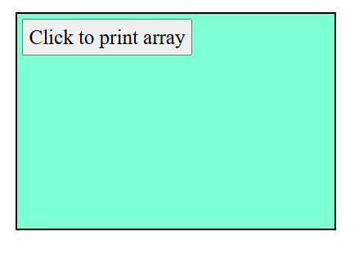 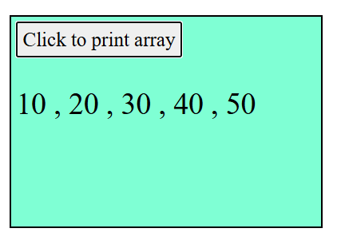

**EXPERIMENT 2.3**

***Experiment 2.3.1:*** ***Implement a js function to change the background of a button on hover***

**Code:**

 <!DOCTYPE html>

 <html lang="en">

 <head>

    <meta charset="UTF-8">

    <meta name="viewport" content="width=device-width, initial-scale=1.0">

    <title>Document</title>

 </head>

 <body>

    <button id="hoverButton">MyButton</button>

    <br>

    <span>HOVER OVER</span>

    <script>

        const button = document.getElementById("hoverButton");

        button.addEventListener("mouseover", function () {

        button.style.backgroundColor = "yellow";

    });

    button.addEventListener("mouseout", function () {

        button.style.backgroundColor = "gray";

    });

    </script>

 </body>

 </html>

**Output:**

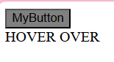

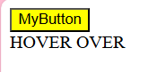

***Experiment 2.3.2: Create a js countdown timer that triggers an event when the timer reaches zero***

**Code:**

<!DOCTYPE html>

 <html lang="en">

 <head>

    <meta charset="UTF-8">

    <meta name="viewport" content="width=device-width, initial-scale=1.0">

    <title>Document</title>

 </head>

 <body>

    <div id="countdownDisplay" style="font-size: 24px; font-weight: bold;"></div>

    <script>

        function startCountdown(durationInSeconds, displayElement) {

        let timeLeft = durationInSeconds;

        const countdownInterval = setInterval(function () {

        let minutes = Math.floor(timeLeft / 60);

        let seconds = timeLeft % 60;

        displayElement.textContent = `${minutes}:${seconds < 10 ? '0' : ''}${seconds}`;

        if (timeLeft <= 0) {

            clearInterval(countdownInterval);

            triggerEvent(); }

        timeLeft--;

        }, 1000);

        }

        function triggerEvent() {

        alert("Time's up!"); }

        document.addEventListener("DOMContentLoaded", function () {

        const display = document.getElementById("countdownDisplay");

        startCountdown(20, display);

           });

    </script>

 </body>

 </html>

**Output:**

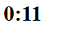 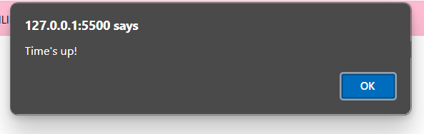

***Experiment 2.3.3: A program to reverse the string  and check if it is palindrome***

**Code:**

<!DOCTYPE html>

<html lang="en">

<head>

    <meta charset="UTF-8">

    <meta name="viewport" content="width=device-width, initial-scale=1.0">

    <title>Document</title>

    <script>

        function reverseString(str) {

        let rev="";

        for (let i=str.length-1; i>=0; i--) {

         rev+=str[i];

        }

        return rev;

        }

        function isPalindrome(str) {

        let reversed = reverseString(str);

        return str === reversed;

        }

        function processString() {

        let inputStr = document.getElementById("inputString").value;

        let charToFind = document.getElementById("charToFind").value;

        document.getElementById("reversedString").innerText = "Reversed String: " + reverseString(inputStr);

        if (isPalindrome(inputStr)) {

        document.getElementById("palindromeCheck").innerText = "The string is a palindrome.";

        } else {

          document.getElementById("palindromeCheck").innerText = "The string is NOT a palindrome.";

        }

        }

    </script>

</head>

<body>

    <h2>String Operations</h2>

    <label for="inputString">Enter a String:</label>

    <input type="text" id="inputString" placeholder="Type a string here">

    <br>

    <br>

    <button onclick="processString()">Check</button>

    <h3>Results:</h3>

    <p id="reversedString"></p>

    <p id="palindromeCheck"></p>

</body>

</html>

**Output:**

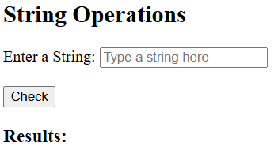

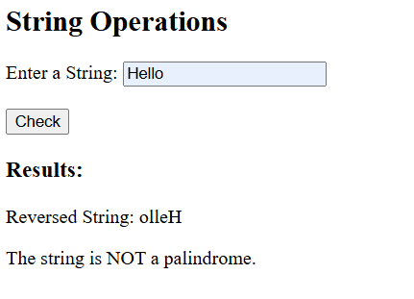

***Experiment 2.3.4: A program to find number of occurrences of character in the string***

**Code:**

<!DOCTYPE html>

  <html lang="en">

  <head>

    <meta charset="UTF-8">

    <meta name="viewport" content="width=device-width, initial-scale=1.0">

    <title>Document</title>

  </head>

  <body>

            <h2>String Operations</h2>

            <label for="inputString">Enter a String:</label>

            <input type="text" id="inputString" placeholder="Type a string here">

            <br>

            <br>

            <label for="charToFind">Character to Count:</label>

            <input type="text" id="charToFind" maxlength="1" placeholder="e.g., a">

            <br><br>

            <button onclick="processString()">Check</button>

            <h3>Results:</h3>

            <p id="charCount"></p>

    <script>

        function countCharacterOccurrences(str, char) {

        let count = 0;

        for (let i = 0; i < str.length; i++) {

        if (str[i] === char) {

            count++;

        }

        }

        return count;

        }

        function processString() {

            let inputStr = document.getElementById("inputString").value;

            let charToFind = document.getElementById("charToFind").value;

            // Character Occurrences

            if (charToFind) {

                document.getElementById("charCount").innerText = `The character '${charToFind}' appears ${countCharacterOccurrences(inputStr, charToFind)} times.`;

            } else {

                document.getElementById("charCount").innerText = "Please enter a character to count.";

            }

        }

    </script>

  </body>

  </html>

**Output:**

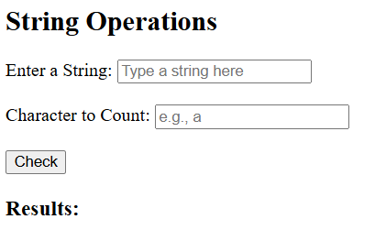

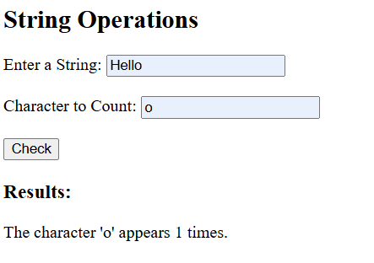

**EXPERIMENT 3**

***Experiment 3.1:Calculator***

**Code:**

<!DOCTYPE html>

<html lang="en">

<head>

    <meta charset="UTF-8">

    <meta name="viewport" content="width=device-width, initial-scale=1.0">

    <title>Simple Calculator</title>

    <style>

        body {

            font-family: Arial, sans-serif;

            text-align: center;

            background-color: #f4f4f4;

            margin-top: 50px;

        }

        .container {

            background: white;

            width: 300px;

            margin: auto;

            padding: 20px;

            border-radius: 10px;

            box-shadow: 0 0 10px rgba(0, 0, 0, 0.1);

        }

        input {

            width: 80%;

            padding: 8px;

            margin: 10px;

            border: 1px solid #ddd;

            border-radius: 5px;

            text-align: center;

        }

        button {

            padding: 10px;

            margin: 5px;

            width: 60px;

            font-size: 16px;

            cursor: pointer;

            border: none;

            border-radius: 5px;

            background: #28a745;

            color: white;

        }

        button:hover {

            background: #218838;

        }

        #result {

            margin-top: 10px;

            font-size: 18px;

            font-weight: bold;

        }

    </style>

</head>

<body>

    <div class="container">

        <h2>Simple Calculator</h2>

        <input type="number" id="num1" placeholder="Enter first number">

        <input type="number" id="num2" placeholder="Enter second number">

        <br>

        <button onclick="calculate('add')">+</button>

        <button onclick="calculate('subtract')">-</button>

        <button onclick="calculate('multiply')">×</button>

        <button onclick="calculate('divide')">÷</button>

        <p id="result"></p>

    </div>

    <script>

        function add(a, b) {

            return a + b;

        }

        function subtract(a, b) {

            return a - b;

        }

        function multiply(a, b) {

            return a * b;

        }

        function divide(a, b) {

            if (b === 0) return "Cannot divide by zero!";

            return a / b;

        }

        function calculate(operation) {

            let num1 = parseFloat(document.getElementById("num1").value);

            let num2 = parseFloat(document.getElementById("num2").value);

            let result;

            if (isNaN(num1) || isNaN(num2)) {

                result = "Please enter valid numbers!";

            } else {

                switch (operation) {

                    case 'add': result = add(num1, num2); break;

                    case 'subtract': result = subtract(num1, num2); break;

                    case 'multiply': result = multiply(num1, num2); break;

                    case 'divide': result = divide(num1, num2); break;

                }

            }

            document.getElementById("result").innerText = "Result: " + result;

        }

    </script>

</body>

</html>

**Output:**

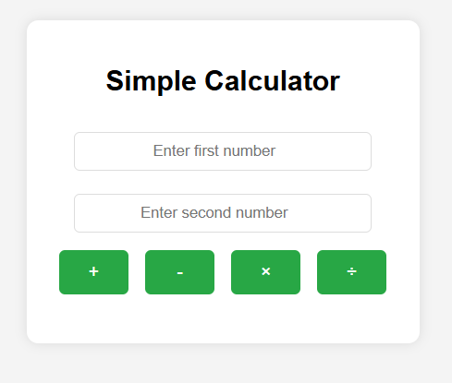

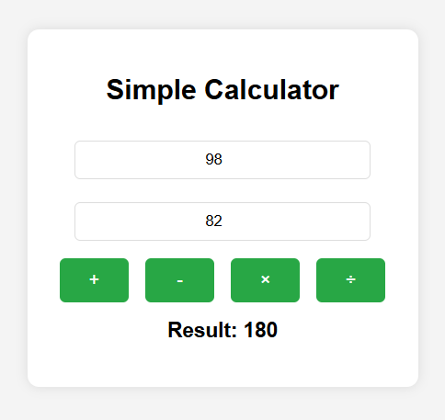

***Experiment 3.2: To-do List***

**Code:**

<!DOCTYPE html>

<html lang="en">

<head>

    <meta charset="UTF-8">

    <meta name="viewport" content="width=device-width, initial-scale=1.0">

    <title>To-Do List</title>

    <style>

        body {

            font-family: Arial, sans-serif;

            background: #f9f9f9;

            text-align: center;

            margin-top: 20px;

        }

        .container {

            display: flex;

            justify-content: space-around;

            margin-top: 30px;

        }

        .panel {

            width: 40%;

            background: white;

            padding: 20px;

            border-radius: 10px;

            box-shadow: 0 0 10px rgba(0, 0, 0, 0.1);

        }

        h2 {

            margin-top: 0;

        }

        input {

            padding: 10px;

            width: 60%;

            border: 1px solid #ccc;

            border-radius: 5px;

        }

        button {

            padding: 10px 15px;

            background: #28a745;

            color: white;

            border: none;

            border-radius: 5px;

            cursor: pointer;

            margin-left: 10px;

        }

        button:hover {

            background: #218838;

        }

        ul {

            list-style: none;

            padding: 0;

        }

        li {

            padding: 10px;

            margin: 8px 0;

            background: #f1f1f1;

            border-radius: 5px;

            display: flex;

            justify-content: space-between;

        }

        .delete-btn {

            background: red;

            color: white;

            border: none;

            padding: 5px 10px;

            border-radius: 5px;

            cursor: pointer;

        }

        .delete-btn:hover {

            background: darkred;

        }

    </style>

</head>

<body>

    <h2>To-Do List</h2>

    <input type="text" id="taskInput" placeholder="Enter a task">

    <button onclick="addTask()">Add Task</button>

    <div class="container">

        <!-- Left Panel: Completed Tasks -->

        <div class="panel">

            <h2>✅ Completed Tasks</h2>

            <ul id="completedTasks"></ul>

        </div>

        <!-- Right Panel: Pending Tasks -->

        <div class="panel">

            <h2>⏳ Pending Tasks</h2>

            <ul id="pendingTasks"></ul>

        </div>

    </div>

    <script>

        function addTask() {

            let taskInput = document.getElementById("taskInput");

            let taskText = taskInput.value.trim();

            if (!taskText) {

                alert("Please enter a task!");

                return;

            }

            let li = document.createElement("li");

            li.innerHTML = `${taskText} <button class="delete-btn" onclick="deleteTask(this)">X</button>`;

            li.addEventListener('click', () => moveToCompleted(li));

            document.getElementById("pendingTasks").appendChild(li);

            taskInput.value = "";

        }

        function moveToCompleted(taskItem) {

            taskItem.remove();

            taskItem.removeEventListener('click', () => moveToCompleted(taskItem));

            document.getElementById("completedTasks").appendChild(taskItem);

        }

        function deleteTask(button) {

            button.parentElement.remove();

        }

    </script>

</body>

</html>

**Output:**

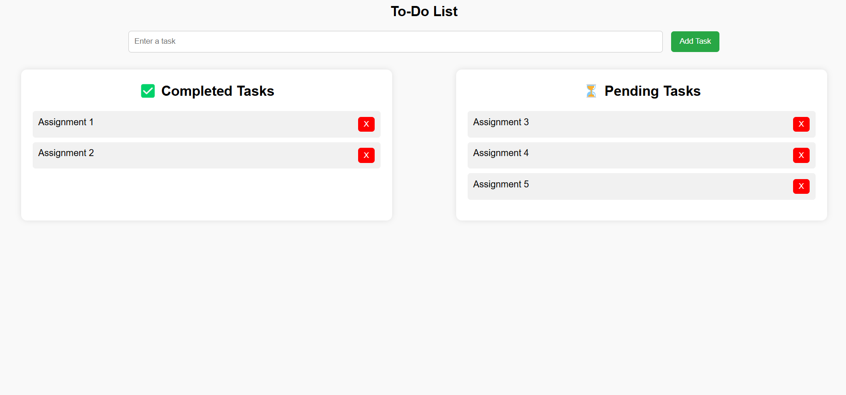

***Experiment 3.3: Registration Form***

**Code:**

<!DOCTYPE html>

<html lang="en">

<head>

    <meta charset="UTF-8">

    <meta name="viewport" content="width=device-width, initial-scale=1.0">

    <title>Document</title>

</head>

<body>

    <fieldset>

        <legend>Form 1</legend>

        <form id="registrationForm">

            <label for="name">Enter Name</label>

            <input type="text"id="name">

            <br><br>

            <label for="age">Enter Age</label>

            <input type="tel" id="age">

            <br><br>

            <input type="submit" value="Submit">

        </form>

        <p id="successMessage" style="color: green;"></p>

    </fieldset>

    <script>

        document.getElementById("registrationForm").addEventListener("submit", function(event) {

        let name = document.getElementById("name").value.trim();

        let age = document.getElementById("age").value.trim();

        let isValid=true;

         if (!name) {

        console.log("Full name is required!");

        return;

    }

    if(!age){

        console.log("Age required");

        return;

    }

     if (isValid===true) {

                document.getElementById("successMessage").textContent = "Registration successful!";

            }

        })

    </script>

</body>

</html>

**Output:**

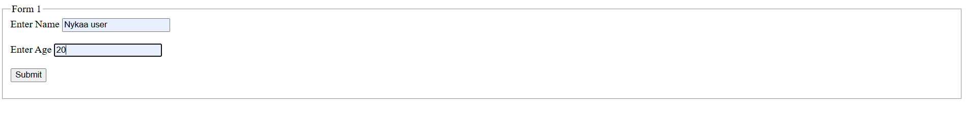

**EXPERIMENT 4**

***My Portfolio***

**Code:**

<!DOCTYPE html>

<html lang="en">

<head>

    <meta charset="UTF-8">

    <meta name="viewport" content="width=device-width, initial-scale=1.0">

    <title>Portfolio Project</title>

    <style>

        body {

            width: 100%;

            height: 100%;

            background-color: #8EC5FC;

            background-image: linear-gradient(62deg, #8EC5FC 0%, #E0C3FC 100%);

            font-family: Arial, sans-serif;

            transition: background 0.5s;

        }

        .dark-mode {

            background: linear-gradient(62deg, #1e1e1e 0%, #3a3a3a 100%);

            color: white;

        }

        .container {

            max-width:100%;

            margin: auto;

            padding: 20px;

            margin: 10px;

        }

        .head {

            display: flex;

            justify-content: space-between;

            align-items: center;

            padding: 10px;

            margin: 10px;

        }

        .nav button, .toggle-dark {

            background-color: rgb(80, 80, 160);

            color: white;

            padding: 8px 15px;

            border: none;

            cursor: pointer;

            transition: 0.3s;

        }

        .nav button:hover, .toggle-dark:hover {

            background-color: rgb(50, 50, 120);

        }

        .bookmark a {

            color: white;

            padding: 10px;

            text-decoration: none;

            transition: color 0.3s;

        }

        .bookmark a:hover {

            color: yellow;

        }

        img {

            border-radius: 50%;

            transition: transform 0.3s;

        }

        img:hover {

            transform: scale(1.1);

        }

        #name{

            padding: 5px;;

           font-family: 'Times New Roman', Times, serif;

           font-size: 30px;

           border: solid purple 2px;

        }

        #About{

            text-align: justify;

        }

        #aboutimg{

            display: flex;

            align-self:self-start;

        }

        #projects a{

            text-decoration: none;

            color: #3a3a3a;

        }

    </style>

</head>

<body>

    <header class="head">

        <div id="name"><span>Adeela Azeez</span></div>

        <nav class="nav">

            <button onclick="scrollToSection('about')">About</button>

            <button onclick="scrollToSection('skills')">Skills</button>

            <button onclick="scrollToSection('projects')">Projects</button>

            <button class="toggle-dark" onclick="toggleDarkMode()">Dark Mode</button>

        </nav>

    </header>

    <div class="container">

        <section id="about">

            <h2>About Me</h2>

            <table>

                <tr>

                    <td><img src="Picture.jpeg" alt="Myself" height="200" width="200" id="aboutimg"></td>

      <td id="About">I aspire to become a full-stack software developer because I am deeply passionate about crafting solutions that bridge the gap between user experience and technical functionality. I find immense satisfaction in building applications that are not only visually appealing but also efficient, scalable, and capable of solving real-world problems. I want to work on projects that seamlessly integrate the frontend and backend, ensuring that every aspect of the application contributes to a smooth and enjoyable user experience.My ultimate dream is to create innovative software solutions that have a meaningful impact, particularly in the fields of business and education. I envision developing tools like management platforms, e-learning applications, and task management systems that empower users, simplify workflows, and enhance productivity. I want to design and implement features such as personalized learning paths, intuitive user interfaces, and robust backend systems that adapt to the evolving needs of users.I see myself constantly learning and evolving in this field, staying updated with the latest technologies and best practices to deliver high-quality solutions. Whether it's using frameworks like React.js and Vue.js for the frontend or leveraging Node.js or Python for backend development, I am excited about building comprehensive applications from scratch. My ultimate goal is to combine creativity, technical expertise, and innovation to leave a lasting impact through the software I create.</td>

                </tr>

            </table>

        </section>

        <section id="skills">

            <h2>Skills</h2>

            <ul>

                <li>C++</li>

                <li>Java</li>

                <li>Artificial Intelligence</li>

                <li>UI/UX Design</li>

            </ul>

        </section>

        <section id="projects">

            <h2>Projects</h2>

            <p>Here are some of my projects...</p>

            <ul>

                <li><a href="../Experiment 1/homepage.html">The Family Restaurant</a></li>

                <li><a href="studysyncclass.html"> StudySyn</a></li>

            </ul>

        </section>

        <section>

            <h2>Education</h2>

            <ul>

                <li>The Lucknow Public Collegiate</li>

                <li>K.R. Mangalam University</li>

            </ul>

        </section>

        <section>

            <h2>Work Experience</h2>

            <ul>

                <li>Intern, Edunet Foundation (June 2024 - July 2024)</li>

                <li>Intern, Codsft (May 2024 - June 2024)</li>

            </ul>

        </section>

        <section>

            <h2>Certifications</h2>

            <ul>

                <li>Artificial Intelligence Fundamentals</li>

                <li>Google UX Design Professional Certificate</li>

                <li>Enterprise-Grade AI & Data Science</li>

            </ul>

        </section>

        <section>

            <h2>Contact Me</h2>

            <form id="contactForm">

                <input type="text" id="nameInput" placeholder="Your Name" required>

                <input type="email" id="emailInput" placeholder="Your Email" required>

                <button type="submit">Submit</button>

            </form>

            <p id="formMessage"></p>

        </section>

    </div>

    <footer>

        <p>&copy; Adeela Azeez, All rights reserved</p>

    </footer>

    <script>

        function toggleDarkMode() {

            document.body.classList.toggle("dark-mode");

        }

        function scrollToSection(sectionId) {

            document.getElementById(sectionId).scrollIntoView({behavior: "smooth"});

        }

        document.getElementById("contactForm").addEventListener("submit", function(event) {

            event.preventDefault();

            document.getElementById("formMessage").innerText = "Thank you for reaching out!";

        });

    </script>

</body>

</html>

**Output:**

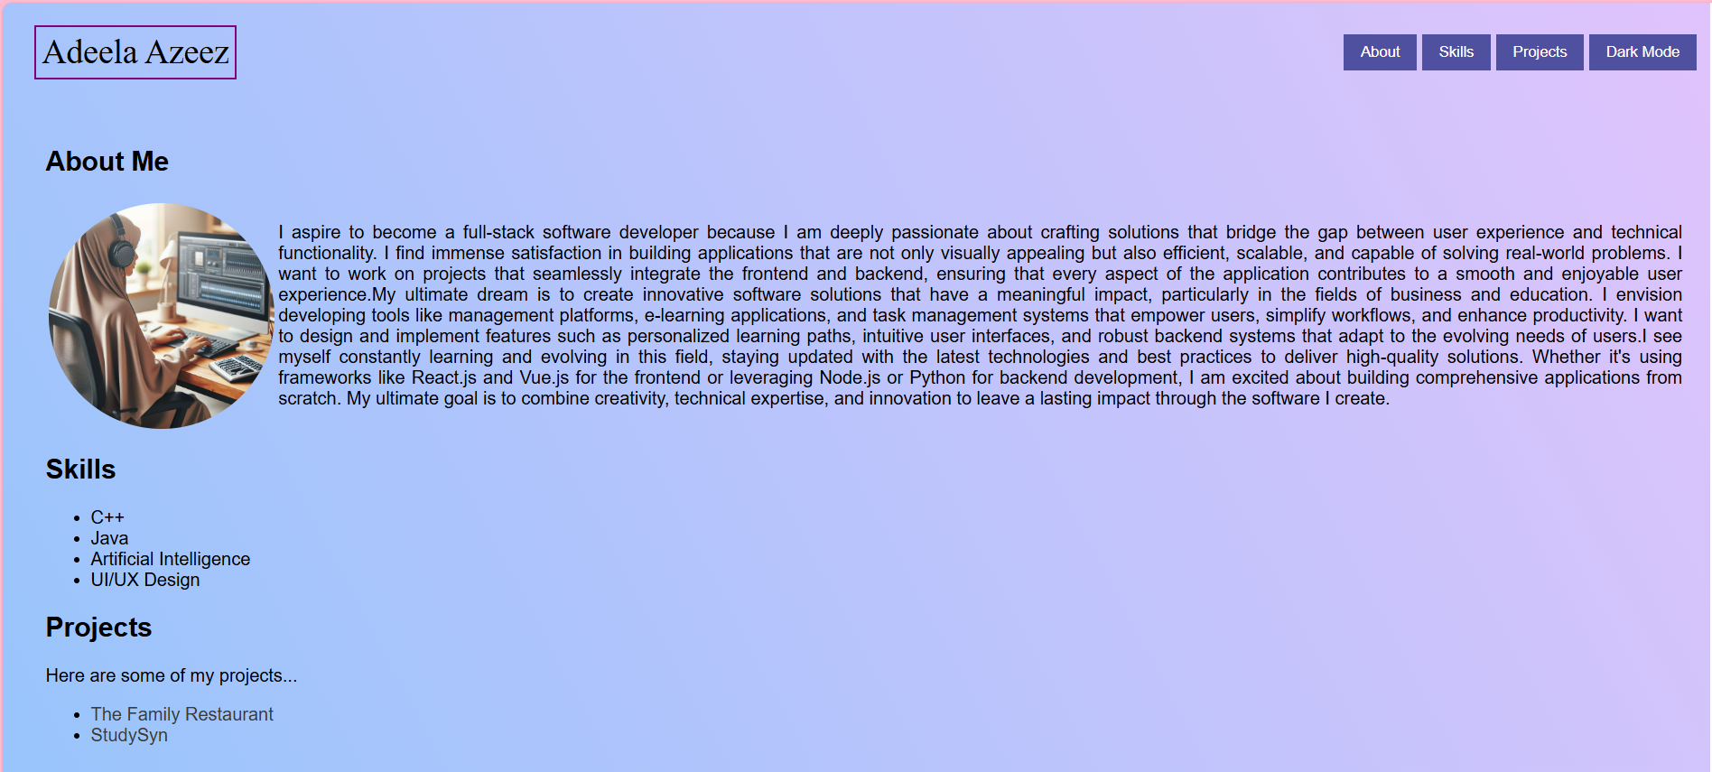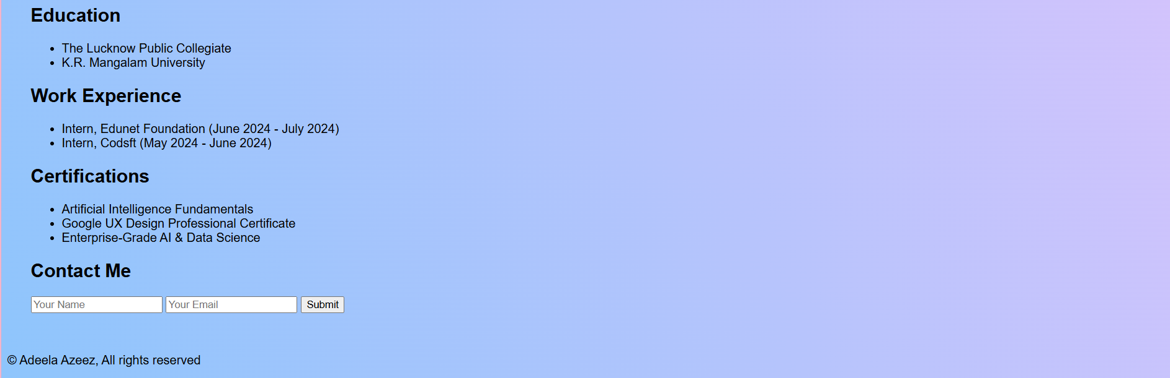

**EXPERIMENT 5**

***Experiment 5.1: Rock Paper Scissor*Code:**

<!DOCTYPE html>

<html lang="en">

<head>

    <meta charset="UTF-8">

    <meta name="viewport" content="width=device-width, initial-scale=1.0">

    <title>Rock Paper Scissors</title>

    <style>

        body {

            font-family: Arial, sans-serif;

            text-align: center;

            margin: 50px;

            background-color: cornsilk;

        }

        .choices {

            margin: 20px;

        }

        .choices button {

            font-size: 20px;

            padding: 10px 20px;

            margin: 10px;

            cursor: pointer;

        }

        #result {

            font-size: 24px;

            margin-top: 20px;

            font-weight: bold;

        }

        #score {

            font-size: 20px;

            margin-top: 10px;

        }

    </style>

</head>

<body>

    <h1>Rock Paper Scissors</h1>

    <div class="choices">

        <button onclick="playGame('rock')">Rock</button>

        <button onclick="playGame('paper')">Paper</button>

        <button onclick="playGame('scissors')">Scissors</button>

    </div>

    <p id="result"></p>

    <p id="score">Player: 0 | Computer: 0</p>

    <script>

        let playerScore = 0;

        let computerScore = 0;

        function playGame(userChoice) {

            const choices = ['rock', 'paper', 'scissors'];

            const computerChoice = choices[Math.floor(Math.random() * choices.length)];

            let result = '';

            if (userChoice === computerChoice) {

                result = "It's a tie!";

            } else if (

                (userChoice === 'rock' && computerChoice === 'scissors') ||

                (userChoice === 'paper' && computerChoice === 'rock') ||

                (userChoice === 'scissors' && computerChoice === 'paper')

            ) {

                result = 'You win!';

                playerScore++;

            } else {

                result = 'You lose!';

                computerScore++;

            }

            document.getElementById('result').innerText = `You chose ${userChoice}. Computer chose ${computerChoice}. ${result}`;

            document.getElementById('score').innerText = `Player: ${playerScore} | Computer: ${computerScore}`;

        }

    </script>

</body>

</html>

**Output:**

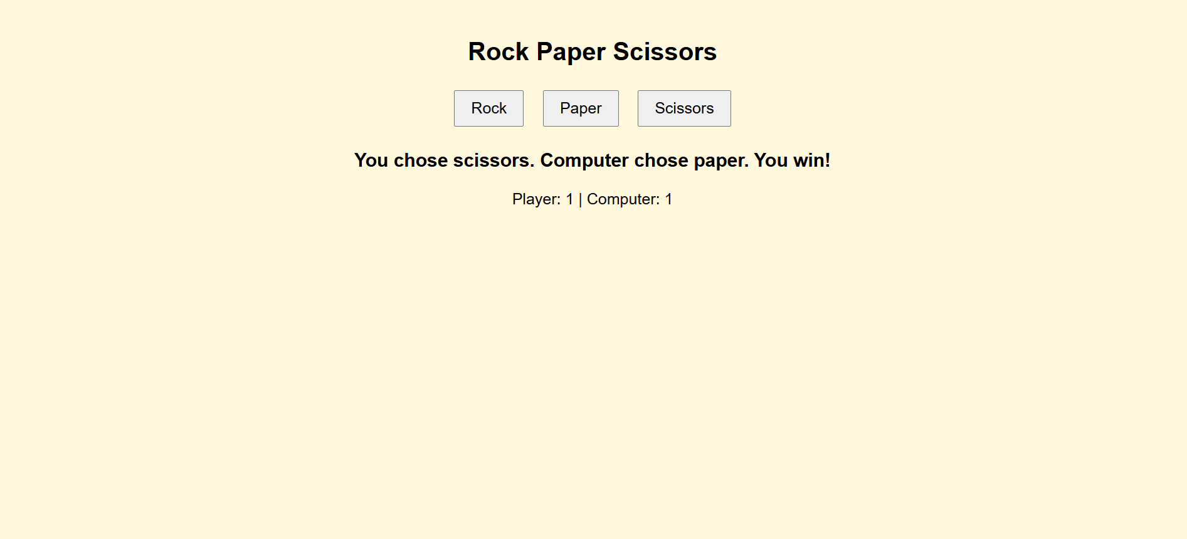

***Experiment 5.2: Weather Forecast WebApp***

**Code:**

<!DOCTYPE html>

<html lang="en">

<head>

    <meta charset="UTF-8">

    <meta name="viewport" content="width=device-width, initial-scale=1.0">

    <title>Weather Portal</title>

    <style>

        body {

            font-family: Arial, sans-serif;

            text-align: center;

            background: linear-gradient(to right, #485158, #00f2fe);

            color: white;

            padding: 50px;

        }

        .container {

            max-width: 400px;

            margin: auto;

            background: rgba(255, 255, 255, 0.2);

            padding: 20px;

            border-radius: 10px;

        }

        input {

            padding: 10px;

            width: 80%;

            margin: 10px 0;

        }

        button {

            padding: 10px 20px;

            background: #000000;

            border: none;

            color: white;

            cursor: pointer;

        }

    </style>

</head>

<body>

    <div class="container">

        <h2>Weather Portal</h2>

        <input type="text" id="city" placeholder="Enter city name">

        <button onclick="showWeather()">Get Weather</button>

        <div id="weather"></div>

    </div>

    <script>

        function showWeather() {

            const city = document.getElementById('city').value;

            if (!city) {

                alert('Please enter a city name');

                return;

            }

            const weatherData = {

                "Lucknow": { temp: 15, description: "Cloudy", humidity: 65, wind: 5 },

                "New Delhi": { temp: 10, description: "Rainy", humidity: 80, wind: 7 },

                "Mumbai": { temp: 30, description: "Sunny", humidity: 40, wind: 3 },

                "Kolkata": { temp: 20, description: "Clear", humidity: 50, wind: 6 }

            };

            if (weatherData[city]) {

                const data = weatherData[city];

                document.getElementById('weather').innerHTML = `

                    <h3>${city}</h3>

                    <p>Temperature: ${data.temp}°C</p>

                    <p>Weather: ${data.description}</p>

                    <p>Humidity: ${data.humidity}%</p>

                    <p>Wind Speed: ${data.wind} m/s</p>

                `;

            } else {

                document.getElementById('weather').innerHTML = `<p>Weather data not available</p>`;

            }

        }

    </script>

</body>

</html>

**Output:**

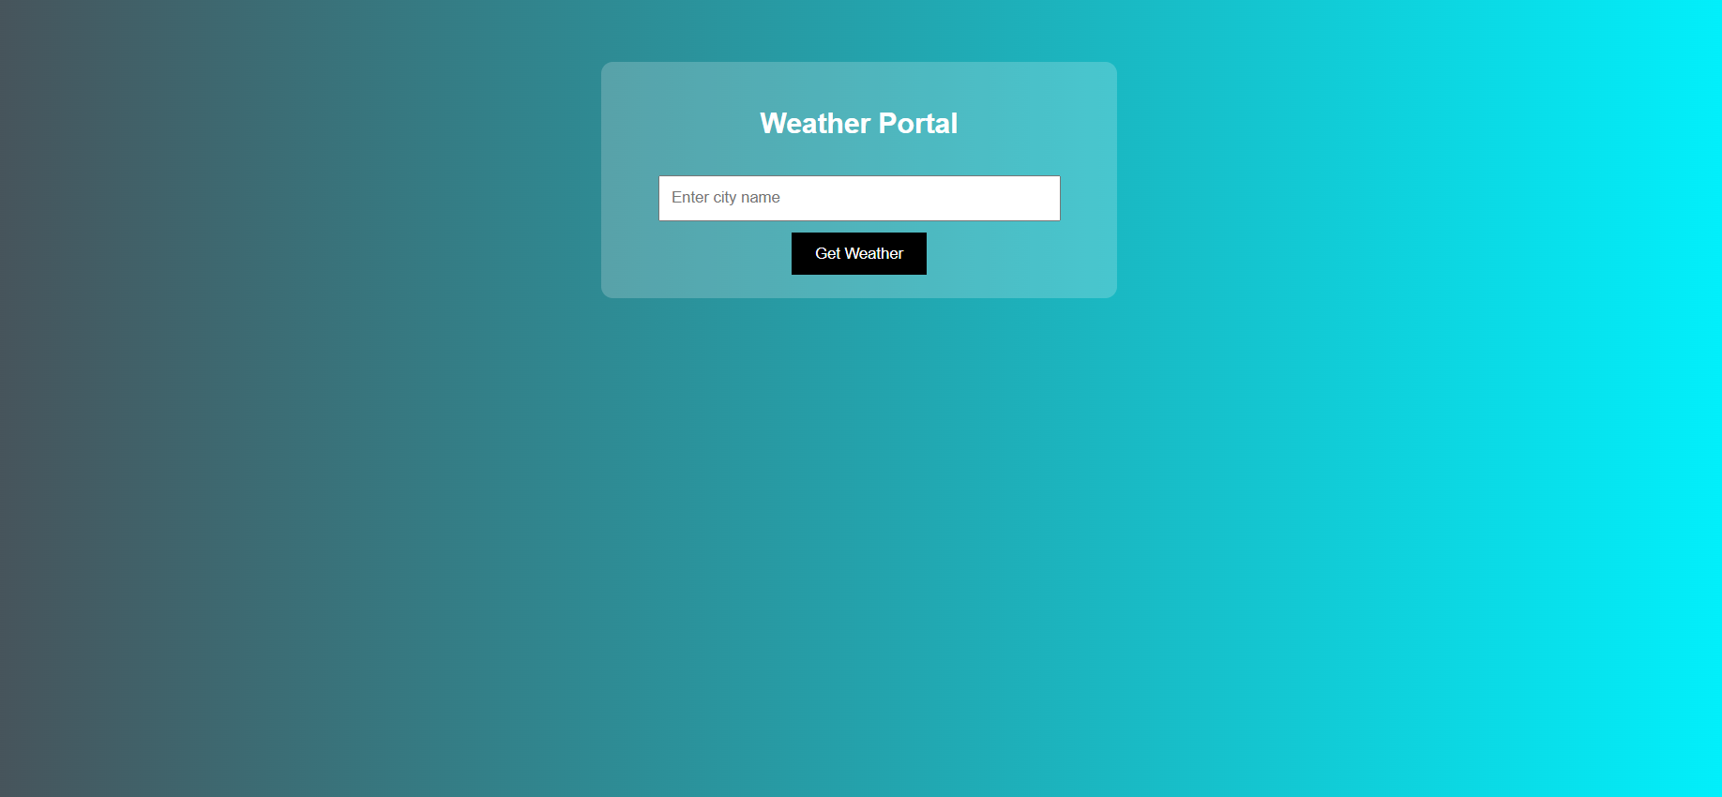

***Experiment 5.3: Movies and Books Library***

**Code:**

<!DOCTYPE html>

<html>

<head>

    <title>Library</title>

    <link rel="stylesheet" href="moviesandbooks.css">

    <style>

        *{

    margin:0;

    padding:0;

}

body{

    height:100%;

    width:99%;

    background-image: radial-gradient( circle 341px at 10% 20%,  rgba(132,94,194,1) 0%, rgba(196,243,251,1) 90% );

    border: solid black 8px;

}

#mainhead{

    font-family:Arial, Helvetica, sans-serif;

}

.container{

    height:100%;

    width:80%;

    margin:auto;

    display: flex;

    flex-direction: column;

    justify-content: center;

    align-items: center;

    padding: 10px;

}

.box1{

    display: flex;

    flex-direction: column;

    justify-content: center;

    align-items: center;

    gap:10px;

    margin:10px;

}

.box2{

    position:relative;

    display: grid;

    grid-template-rows: repeat(2,1fr);

    grid-template-columns: repeat(4, 1fr);

    gap: 10px;

    padding: 10px;;

}

.card{

    border:solid black 2px;

    background-image: radial-gradient( circle farthest-corner at 3.7% 49.8%,  rgba(143,232,255,1) 21.9%, rgba(209,243,251,1) 52.9% );

    gap:10px;

    display:flex;

    flex-direction: column;

    justify-content: space-between;

}

.nameAuthor{

    display: flex;

    flex-direction: column;

}

.author{

    display:flex;

}

.cardfooter{

    padding:5px;

    display:flex;

    justify-content: center;

    align-items: center;

    /* border: solid black 1px; */

    /* border-radius: 20px; */

    margin: 5px;

}

button{

    height:40px;

    width: 100px;

    text-wrap: wrap;

    border-radius: 5px;

    margin:5px;

}

button a{

    text-decoration: none;

    color: black;

}

.cardfooter img{

    border-radius:50%;

}

.card img{

    padding: 0px;

    width:100%;

    transition: all 2s 0.5s;

}

.card img:hover{

    transform: scale(1.01);

}

.card p{

    padding: 5px;

}

.box1 h2{

    font-size: 50px;

}

.box1 p{

    font-size:20px;

    text-align: center;

}

#tit{

    text-decoration: none;

    color: black;

    padding: 5px;

    transition: all 1s 4s;

}

#tit :hover{

    color:rgb(7, 7, 94)

}

@media (max-width:700px)

{

    .box2{

        /* position:relative;

        display: grid; */

        grid-template-rows: repeat(4,1fr);

        grid-template-columns: repeat(2, 1fr);

        /* gap: 10px;

        padding: 10px;; */

    }

}

@media (max-width:200px)

{

    .box2{

        /* position:relative;

        display: grid; */

        grid-template-rows: repeat(8,1fr);

        grid-template-columns: repeat(1, 1fr);

        /* gap: 10px;

        padding: 10px;; */

    }

}

    </style>

</head>

<body>

        <div class="box1">

        <h2 id="mainhead">Movies and Books</h2>

        </div>

        <div class="container">

            <div class="box1">

                <h2>Movies</h2>

                <p>Movies are a popular form of entertainment that combine storytelling, visuals, and sound to create engaging experiences. They come in various genres, such as action, drama, comedy, thriller, and science fiction. Movies can educate, inspire, and evoke emotions, making them a powerful medium for storytelling and cultural expression. With advancements in technology, movies are now available in theaters, on television, and through streaming platforms, making them accessible to a global audience. 🎬✨</p>

            </div>

            <div class="box2">

                <div class="card">

                    <a href="https://youtu.be/J7vzDh2A9nk?si=rbpn2WAP1BH_9-qW"><img src="golmaalagain.jpeg" alt="golmaalagain" height="200px" width="200px"></a>

                    <a id="tit" href="#"><h3>Golmaal Again</h3></a>

                    <p>"Golmaal Again" is a Bollywood comedy film and the fourth installment in the "Golmaal" series. Directed by Rohit Shetty, it features an ensemble cast including Ajay Devgn, Parineeti Chopra, Tabu, Arshad Warsi, and others.</p>

                    <div class="cardfooter">

                        <button><a href="https://youtu.be/J7vzDh2A9nk?si=rbpn2WAP1BH_9-qW">Watch Now</a></button>

                    </div>

                </div>

                <div class="card">

                        <a href="https://www.youtube.com/watch?v=mwVKwP0V7Q4"><img src="airlift.jpeg" alt="airlift" height="200px" width="200px"></a>

                        <a id="tit" href="#"><h3>Airlift</h3></a>

                        <p>A 2016 patriotic thriller starring Akshay Kumar and Nimrat Kaur, 'Airlift' depicts India's heroic evacuation mission during the Gulf War, showcasing the courage and resilience of ordinary citizens in extraordinary circumstances</p>

                        <div class="cardfooter">

                            <button><a href="https://www.youtube.com/watch?v=mwVKwP0V7Q4">Watch Now</a></button>

                        </div>

                </div>

                <div class="card">

                    <a href="https://www.youtube.com/watch?v=Cur8R1Tid58"><img src="blank.jpeg" alt="blank" height="200px" width="200px"></a>

                    <a id="tit" href="#"><h3>Blank</h3></a>

                    <p>Released in 2019, 'Blank' is an action thriller featuring Sunny Deol. The film centers around a suicide bomber who loses his memory, leading to a tense investigation as authorities race against time to prevent a potential disaster</p>

                    <div class="cardfooter">

                        <button><a href="https://www.youtube.com/watch?v=Cur8R1Tid58">Watch Now</a></button>

                    </div>

                </div>

                <div class="card">

                        <a href="https://www.youtube.com/watch?v=7qSV-RXUKuc"><img src="golmaalagain.jpeg" alt="golmaalagain" height="200px" width="200px"></a>

                        <a id="tit" href="#"><h3>Hansa</h3></a>

                        <p>A 2012 independent film directed by Manav Kaul, 'Hansa' is set in a Himalayan village and follows young Hansa and his sister Cheeku as they search for their missing father amidst mounting debts and societal pressures..</p>

                        <div class="cardfooter">

                            <button><a href="https://www.youtube.com/watch?v=7qSV-RXUKuc">Watch Now</a></button>

                        </div>

                </div>

                <div class="card">

                    <a href="https://www.youtube.com/watch?v=WMuMuvew-OU"><img src="striker.jpeg" alt="striker" height="200px" width="200px"></a>

                    <a id="tit" href="#"><h3>Striker</h3></a>

                    <p>'Striker' (2010) is an action drama starring Siddharth, portraying the life of Suryakant Sarang, a carrom player navigating challenges in the underbelly of Mumbai during the late 1980s and early 1990s</p>

                    <div class="cardfooter">

                        <button><a href="https://www.youtube.com/watch?v=WMuMuvew-OU">Watch Now</a></button>

                    </div>

                </div>

                <div class="card">

                        <a href="https://www.youtube.com/watch?v=example_link"><img src="love you hamesha.jpeg" alt="golmaalagain" height="200px" width="200px"></a>

                        <a id="tit" href="#"><h3>Love You Hamesha</h3></a>

                        <p>A 1999 romantic film featuring Akshaye Khanna and Sonali Bendre, 'Love You Hamesha' explores the journey of young love and the challenges faced by a couple striving to be together against societal odds.</p>

                        <div class="cardfooter">

                            <button><a href="https://www.youtube.com/watch?v=example_link">Watch Now</a></button>

                        </div>

                </div>

                <div class="card">

                    <a href="https://www.youtube.com/watch?v=example_link"><img src="nirahuahindustani.jpeg" alt="nirahuahindustani" height="200px" width="200px"></a>

                    <a id="tit" href="#"><h3>Nirahua Hindustani</h3></a>

                    <p>A 2014 Bhojpuri-language action-romance-comedy film starring Dinesh Lal Yadav and Amrapali Dubey, 'Nirahua Hindustani' depicts a villager's adventures in Mumbai as he navigates love and challenges in the big city.</p>

                    <div class="cardfooter">

                        <button><a href="https://www.youtube.com/watch?v=example_link">Watch Now</a></button>

                    </div>

                </div>

                <div class="card">

                        <a href="https://www.youtube.com/watch?v=example_link"><img src="amarjyoti.jpeg" alt="amarjyoti" height="200px" width="200px"></a>

                        <a id="tit" href="#"><h3>Amar Jyoti</h3></a>

                        <p>A 1936 classic directed by V. Shantaram, 'Amar Jyoti' features Durga Khote as a rebellious female pirate challenging societal norms and fighting for justice in a patriarchal society. </p>

                        <div class="cardfooter">

                            <button><a href="https://www.youtube.com/watch?v=example_link">Watch Now</a></button>

                        </div>

                </div>

        </div>

        </div>

        <div class="container">

            <div class="box1">

                <h2>Books</h2>

                <p>Books are a primary source of knowledge, entertainment, and inspiration. They come in various genres, including fiction, non-fiction, biographies, self-help, and academic texts. Books help expand vocabulary, improve critical thinking, and enhance imagination. With the rise of technology, books are available in digital formats (eBooks) and audiobooks, making reading more accessible. Whether for learning or leisure, books play a crucial role in personal and intellectual growth. 📚✨</p>

            </div>

            <div class="box2">

                <div class="card">

                    <a href="http://www.seas.gwu.edu/~adagroup/sigada-website/barnes-html/intro.html"><img src="ADA 95.jpg" alt="golmaalagain" height="200px" width="200px"></a>

                    <a id="tit" href="#"><h3>ADA 95</h3></a>

                    <p>Ada is a language of special value in the development of large programs which must work reliably. This document introduces Ada 95, which increases the flexibility of Ada making it applicable to wider domains but retains the inherent reliability.</p>

                    <div class="cardfooter">

                        <button><a href="http://www.seas.gwu.edu/~adagroup/sigada-website/barnes-html/intro.html">Read Now</a></button>

                    </div>

                </div>

                <div class="card">

                    <a href="http://www.seas.gwu.edu/~adagroup/sigada-website/barnes-html/intro.html"><img src="ADA 95.jpg" alt="golmaalagain" height="200px" width="200px"></a>

                    <a id="tit" href="#"><h3>ADA 95</h3></a>

                    <p>Ada is a language of special value in the development of large programs which must work reliably. This document introduces Ada 95, which increases the flexibility of Ada making it applicable to wider domains but retains the inherent reliability.</p>

                    <div class="cardfooter">

                        <button><a href="http://www.seas.gwu.edu/~adagroup/sigada-website/barnes-html/intro.html">Read Now</a></button>

                    </div>

                </div>

                <div class="card">

                    <a href="http://www.seas.gwu.edu/~adagroup/sigada-website/barnes-html/intro.html"><img src="ADA 95.jpg" alt="golmaalagain" height="200px" width="200px"></a>

                    <a id="tit" href="#"><h3>ADA 95</h3></a>

                    <p>Ada is a language of special value in the development of large programs which must work reliably. This document introduces Ada 95, which increases the flexibility of Ada making it applicable to wider domains but retains the inherent reliability.</p>

                    <div class="cardfooter">

                        <button><a href="http://www.seas.gwu.edu/~adagroup/sigada-website/barnes-html/intro.html">Read Now</a></button>

                    </div>

                </div>

                <div class="card">

                    <a href="http://www.seas.gwu.edu/~adagroup/sigada-website/barnes-html/intro.html"><img src="ADA 95.jpg" alt="golmaalagain" height="200px" width="200px"></a>

                    <a id="tit" href="#"><h3>ADA 95</h3></a>

                    <p>Ada is a language of special value in the development of large programs which must work reliably. This document introduces Ada 95, which increases the flexibility of Ada making it applicable to wider domains but retains the inherent reliability.</p>

                    <div class="cardfooter">

                        <button><a href="http://www.seas.gwu.edu/~adagroup/sigada-website/barnes-html/intro.html">Read Now</a></button>

                    </div>

                </div>

                <div class="card">

                    <a href="http://www.seas.gwu.edu/~adagroup/sigada-website/barnes-html/intro.html"><img src="ADA 95.jpg" alt="golmaalagain" height="200px" width="200px"></a>

                    <a id="tit" href="#"><h3>ADA 95</h3></a>

                    <p>Ada is a language of special value in the development of large programs which must work reliably. This document introduces Ada 95, which increases the flexibility of Ada making it applicable to wider domains but retains the inherent reliability.</p>

                    <div class="cardfooter">

                        <button><a href="http://www.seas.gwu.edu/~adagroup/sigada-website/barnes-html/intro.html">Read Now</a></button>

                    </div></div>

                <div class="card">

                    <a href="http://www.seas.gwu.edu/~adagroup/sigada-website/barnes-html/intro.html"><img src="ADA 95.jpg" alt="golmaalagain" height="200px" width="200px"></a>

                    <a id="tit" href="#"><h3>ADA 95</h3></a>

                    <p>Ada is a language of special value in the development of large programs which must work reliably. This document introduces Ada 95, which increases the flexibility of Ada making it applicable to wider domains but retains the inherent reliability.</p>

                    <div class="cardfooter">

                        <button><a href="http://www.seas.gwu.edu/~adagroup/sigada-website/barnes-html/intro.html">Read Now</a></button>

                    </div>

                </div>

                <div class="card">

                    <a href="http://www.seas.gwu.edu/~adagroup/sigada-website/barnes-html/intro.html"><img src="ADA 95.jpg" alt="golmaalagain" height="200px" width="200px"></a>

                    <a id="tit" href="#"><h3>ADA 95</h3></a>

                    <p>Ada is a language of special value in the development of large programs which must work reliably. This document introduces Ada 95, which increases the flexibility of Ada making it applicable to wider domains but retains the inherent reliability.</p>

                    <div class="cardfooter">

                        <button><a href="http://www.seas.gwu.edu/~adagroup/sigada-website/barnes-html/intro.html">Read Now</a></button>

                    </div>

                </div>

                <div class="card">

                    <a href="http://www.seas.gwu.edu/~adagroup/sigada-website/barnes-html/intro.html"><img src="ADA 95.jpg" alt="golmaalagain" height="200px" width="200px"></a>

                    <a id="tit" href="#"><h3>ADA 95</h3></a>

                    <p>Ada is a language of special value in the development of large programs which must work reliably. This document introduces Ada 95, which increases the flexibility of Ada making it applicable to wider domains but retains the inherent reliability.</p>

                    <div class="cardfooter">

                        <button><a href="http://www.seas.gwu.edu/~adagroup/sigada-website/barnes-html/intro.html">Read Now</a></button>

                    </div>

                </div>

             </div>

        </div>

</body>

</html>

**Output:**

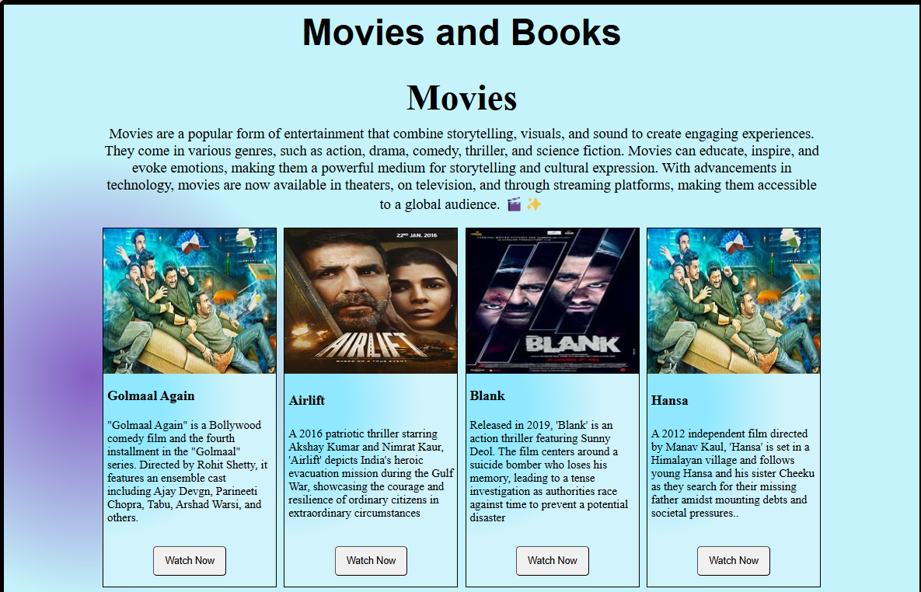 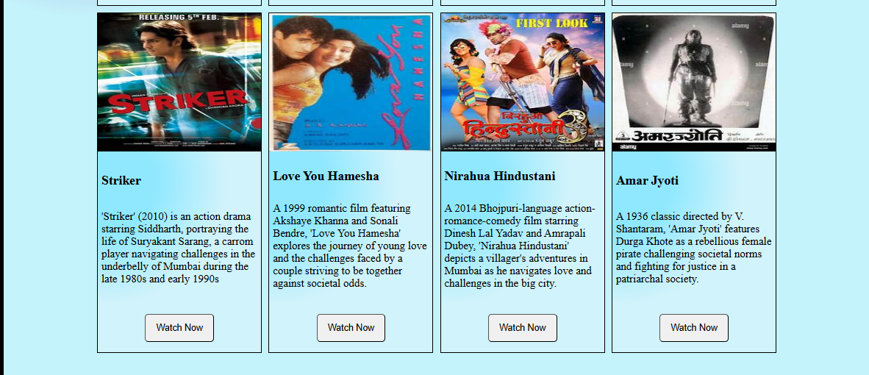

**EXPERIMENT 6**

***Write a JavaScript program to show implementation of:***

***i) If, while for loops***

***ii) Arrays***

**Code:**

<!DOCTYPE html>

<html lang="en">

<head>

    <meta charset="UTF-8">

    <meta name="viewport" content="width=device-width, initial-scale=1.0">

    <title>Random Quote Generator</title>

    <style>

        body {

            font-family: 'Times New Roman', Times, serif;

            text-align: center;

            margin: 20px;

            background: rgb(63,94,251);

            background: linear-gradient(90deg, rgba(63,94,251,1) 0%, rgba(252,70,107,1) 100%);

        }

        button {

            margin: 10px;

            padding: 10px;

            font-size: 16px;

            font-family: 'Times New Roman', Times, serif;

            border: 2px solid black;

            border-radius: 10px;

            background-color: rgb(202, 249, 249);

            font-weight: bold;

        }

        .quote-box {

            background: #e2d7d7;

            margin: 20px auto;

            padding: 20px;

            width: 50%;

            border-radius: 5px;

            font-size: 18px;

            font-weight: bold;

            border: solid 2px;

        }

        h2{

            font-family: 'Times New Roman', Times, serif;

            font-size: 60px;

            color: #f4f4f4;

        }

    </style>

</head>

<body>

    <h2>Give Yourself a Thought</h2>

    <button onclick="generateQuote()">Generate Quote</button>

    <div class="quote-box" id="quoteBox">Click the button to see a quote!</div>

    <script>

        let quotes = [

            "The only limit to our realization of tomorrow is our doubts of today.",

            "Do what you can, with what you have, where you are.",

            "Success is not final, failure is not fatal: it is the courage to continue that counts.",

            "You miss 100% of the shots you don’t take.",

            "Hardships often prepare ordinary people for an extraordinary destiny.",

            "Believe you can and you're halfway there.",

            "It does not matter how slowly you go as long as you do not stop.",

            "Act as if what you do makes a difference. It does.",

            "Quality is not an act, it is a habit.",

            "The best way to predict the future is to create it."

        ];

        let lastQuoteIndex = -1;

        function generateQuote() {

            if (quotes.length === 0) {

                document.getElementById("quoteBox").textContent = "No quotes available.";

                return;

            }

            let index;

            do {

                index = Math.floor(Math.random() * quotes.length);

            } while (index === lastQuoteIndex);

            lastQuoteIndex = index;

            document.getElementById("quoteBox").textContent = quotes[index];

        }

    </script>

</body>

</html>

**Output:**

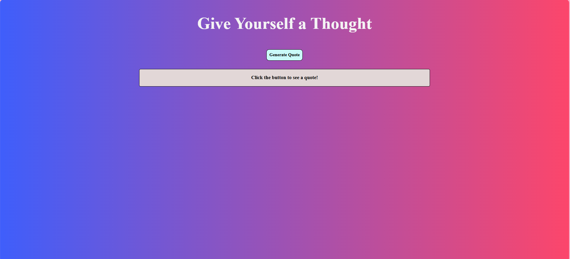

**EXPERIMENT 7**

***Experiment 7.1: Write a JavaScript program to print following pattern:***

*  
* *  
* * *  
* * * *

**Code:**

<!DOCTYPE html>

<html lang="en">

<head>

    <meta charset="UTF-8">

    <meta name="viewport" content="width=device-width, initial-scale=1.0">

    <title>Print Pattern</title>

</head>

<body>

    <script>

        let rows = 4; // Number of rows

        let pattern = "";

        for (let i = 1; i <= rows; i++) {

            for (let j = 1; j <= i; j++) {

                pattern += "* ";

            }

            pattern += "<br>";

        }

        document.write(pattern);

    </script>

</body>

</html>

**Output:**

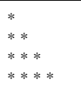

***Experiment 7.2: Write a JavaScript program to print following pattern:***

1  
1 2  
1 2 3  
1 2 3 4

**Code:**

<!DOCTYPE html>

<html lang="en">

<head>

    <meta charset="UTF-8">

    <meta name="viewport" content="width=device-width, initial-scale=1.0">

    <title>Print Pattern</title>

</head>

<body>

    <script>

        let rows = 4; // Number of rows

        let pattern = "";

        for (let i = 1; i <= rows; i++) {

            for (let j = 1; j <= i; j++) {

                pattern += " "+j;

            }

            pattern += "<br>";

        }

        document.write(pattern);

    </script>

</body>

</html>

**Output:**

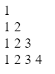

***Experiment 7.3: Write a JavaScript program to print following pattern:***

         *  
       * * *  
     * * * * *  
   * * * * * * *  
* * * * * * * * *

**Code:**

<!DOCTYPE html>

<html lang="en">

<head>

    <meta charset="UTF-8">

    <meta name="viewport" content="width=device-width, initial-scale=1.0">

    <title>Print Pyramid Pattern</title>

</head>

<body>

    <script>

        let rows = 5;

        let pattern = "";

        for (let i = 1; i <= rows; i++) {

            for (let j = 0; j < rows - i; j++) {

                pattern += "&nbsp;&nbsp;"; // Spaces for alignment

            }

            for (let k = 0; k < 2 * i - 1; k++) {

                pattern += " * ";

            }

            pattern += "<br>";

        }

        document.write(pattern);

    </script>

</body>

</html>

**Output:**

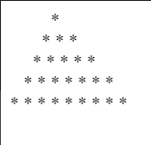

***Experiment 7.4: Write a JavaScript program to print following pattern:***

         1  
       1 1 1  
     1 1 1 1 1  
   1 1 1 1 1 1 1  
1 1 1 1 1 1 1 1 1

**Code:**

<!DOCTYPE html>

<html lang="en">

<head>

    <meta charset="UTF-8">

    <meta name="viewport" content="width=device-width, initial-scale=1.0">

    <title>Print Pyramid Pattern</title>

</head>

<body>

    <script>

        let rows = 5;

        let pattern = "";

        for (let i = 1; i <= rows; i++) {

            for (let j = 0; j < rows - i; j++) {

                pattern += "&nbsp;&nbsp;"; // Spaces for alignment

            }

            for (let k = 0; k < 2 * i - 1; k++) {

                pattern += " 1 ";

            }

            pattern += "<br>";

        }

        document.write(pattern);

    </script>

</body>

</html>

**Output:**

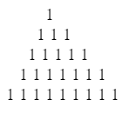

**EXPERIMENT 8**

***Create an e-commerce website using HTML, CSS and JavaScript***

**Code:**

<!DOCTYPE html>

<html>

<head>

    <title>Ecommerce Website</title>

    <style>

*{

    margin:0;

    padding:0;

}

body{

    height:100%;

    width:99%;

    background-color: rgb(255, 255, 255);

    border: solid black 8px;

}

.container{

    height:100%;

    width:80%;

    margin:auto;

    display: flex;

    flex-direction: column;

    justify-content: center;

    align-items: center;

    padding: 10px;

}

.box1{

    display: flex;

    flex-direction: column;

    justify-content: center;

    align-items: center;

    gap:10px;

    margin:10px;

}

.box2{

    position:relative;

    display: grid;

    grid-template-rows: repeat(2,1fr);

    grid-template-columns: repeat(4, 1fr);

    gap: 10px;

    padding: 10px;;

}

.card{

    border:solid black 2px;

    background-color: antiquewhite;

    gap:10px;

    display:flex;

    flex-direction: column;

    justify-content: space-between;

}

.nameAuthor{

    display: flex;

    flex-direction: column;

}

.author{

    display:flex;

}

.cardfooter{

    padding:5px;

    display:flex;

    justify-content: space-between;

    border: solid black 1px;

    border-radius: 20px;

    margin: 5px;

}

button{

    height:40px;

    width: 60px;

    text-wrap: wrap;

    border-radius: 5px;

    margin:5px;

}

.cardfooter img{

    border-radius:50%;

}

.card img{

    padding: 0px;

    width:100%;

    transition: all 2s 0.5s;

}

.card img:hover{

    transform: scale(1.01);

}

.card p{

    padding: 5px;

}

.box1 h2{

    font-size: 50px;

}

.box1 p{

    font-size:20px;

    text-align: center;

}

#tit{

    text-decoration: none;

    color: black;

    padding: 5px;

    transition: all 1s 4s;

}

#tit :hover{

    color:rgb(7, 7, 94)

}

@media (max-width:700px)

{

    .box2{

        /* position:relative;

        display: grid; */

        grid-template-rows: repeat(4,1fr);

        grid-template-columns: repeat(2, 1fr);

        /* gap: 10px;

        padding: 10px;; */

    }

}

@media (max-width:200px)

{

    .box2{

        /* position:relative;

        display: grid; */

        grid-template-rows: repeat(8,1fr);

        grid-template-columns: repeat(1, 1fr);

        /* gap: 10px;

        padding: 10px;; */

    }

}

#productdetails li{

    list-style: none;

}

</style>

</head>

<body>

        <div class="container">

            <div class="box1">

                <h2>Ecommerce Website</h2>

                <p>Lorem ipsum dolor sit, amet consectetur adipisicing elit. Deserunt recusandae quaerat quia accusamus dignissimos mollitia nesciunt aperiam ipsa cupiditate minus!</p>

                <button><a href="cart.html"><img src="cart.png" alt="cart" height="60px" width="60px"></a></button>

            </div>

            <div class="box2">

                <div class="card">

                    <h3>Laptop</h3>

                        <img src="laptop.jpg" alt="Laptop" height="200" width="200">

                        <p><b>Description:</b>High Performance laptop with latest processor and ample storage</p>

                            <p><b>Price:</b> Rs. 47999</p>

                            <p><b>Availabilty:</b> In Stock</p></td>

                    <ul id="productdetails">

                        <li>Brand   Lenovo</li>

                        <li>Model Name  E14 Gen 5 AMD</li>

                        <li>Screen Size 14 Inches</li>

                        <li>Colour  Black</li>

                        <li>Hard Disk Size  512 GB</li>

                        <li>CPU Model   Ryzen 5</li>

                        <li>RAM Memory Installed Size   8 GB</li>

                        <li>Operating System    Windows 11 Home</li>

                        <li>Special Feature Backlit Keyboard</li>

                        <li>Graphics Card Description   Integrated</li>

                    </ul>

                    <p><a href="https://www.amazon.in/Lenovo-ThinkPad-Graphics-Keyboard-21JRS00T00/dp/B0C7J16NYC/ref=sr_1_1_sspa?crid=2H02ZQTY7BSAT&dib=eyJ2IjoiMSJ9.0LY3g6TAbc7qQ1fhYv9CiBMZe6FNY4Zx23gnzITv6g0qpjuNszzhgMgooOBxkg7j4tqb1ygYIyOGjQGvYBy8evs3iVn5pxe2m1oTrrjtum5ST5dDWadtEVZl5yM4RosEAdVVfb1JqJfbO3Bl16J-DSmQHgVGW1cMNDPMQbpJZQR5ZUJhmdLxrMBp9WMKbee6LNWv5H-HgF7LmP1L25mcTvzKDp9S0aNS_RzyTDQNmfA.2kVKuqY4XEdPPfmrh4AlHslUfkEsRtCIwFsnDqsqE3Q&dib_tag=se&keywords=laptop&qid=1738080965&sprefix=laptop%2Caps%2C248&sr=8-1-spons&sp_csd=d2lkZ2V0TmFtZT1zcF9hdGY&th=1">View Details</a></p>

                    <button onclick="addToCart('Laptop', 47999)">Add to Cart</button>

                </div>

                <div class="card">

                    <h3>Smart Phone</h3>

                        <img src="smartphone.jpg" alt="smartphone" height="200" width="200">

                            <p><b>Description:</b>A high-performance smartphone with the latest processor and ample storage.</p>

                                <p><b>Price:</b> Rs.6099</p>

                                <p><b>Availabilty:</b> In Stock</p>

                        <ul id="productdetails">

                            <li><b>Brand:</b>   Tecno </li>

                            <li><b>Connectivity Technology:</b> Bluetooth, Infrared, Wi-Fi, USB</li>

                            <li><b>Model Name</b>   POP 9</li>

                            <li><b>Speaker Type:</b>    Surround Sound</li>

                            <li><b>Net Quantity</b> 1 Count</li>

                        </ul>

                        <p><a href="https://www.amazon.in/Tecno-Glittery-Mediatek-Speaker-Charging/dp/B0DKP5T9F9?ref_=Oct_d_onr_d_1805560031_1&pd_rd_w=1QNPp&content-id=amzn1.sym.6994f97b-af7d-4405-a303-8aac5f8b11eb&pf_rd_p=6994f97b-af7d-4405-a303-8aac5f8b11eb&pf_rd_r=Q70G4V5AJEBESXKB1S1D&pd_rd_wg=dVYMj&pd_rd_r=871ae346-c3d9-4f21-bf5c-659126e348ad&pd_rd_i=B0DKP5T9F9&th=1">View Details</a></p>

                        <button onclick="addToCart('Smartphone', 6099)">Add to Cart</button>

                </div>

                <div class="card">

                    <h3>Smart Watch</h3>

                        <img src="watch.jpg" alt="watch" height="200" width="200">

                            <p><b>Description:</b>High-performance smartwatch with the latest technology and advanced health-tracking features.</p>

                                <p><b>Price:</b> Rs.2099</p>

                                <p><b>Availabilty:</b> In Stock</p>

                        <ul id="productdetails">

                            <li><b>Special Feature: </b>Touchscreen, Lightweight, Alarm Clock, Activity Tracker, Notifications</li>

                            <li><b>Connectivity Technology</b>: Bluetooth</li>

                            <li><b>Wireless Communication:</b> Standard Bluetooth</li>

                            <li><b>GPS:</b> Built-in GPS</li>

                            <li><b>Shape:</b> Rectangular  </li>

                        </ul>

                        <p><a href="https://www.amazon.in/dp/B0DMDVLD8K/?_encoding=UTF8&ref_=cct_cg_BULATVHB_6a1&pf_rd_p=23acc23f-4492-434e-bebd-a91379f876c6&pf_rd_r=STEK4K29R5XJ025AZWT0&th=1">View Details</a></p>

                        <button >Add to Cart</button>

                </div>

                <div class="card">

                    <h3>Smart Watch</h3>

                        <img src="earphones.png" alt="watch" height="200" width="200">

                            <p><b>Description:</b>High-performance smartwatch with the latest technology and advanced health-tracking features.</p>

                                <p><b>Price:</b> Rs.365</p>

                                <p><b>Availabilty:</b> In Stock</p>

                        <ul id="productdetails">

                           <li><b>Brand:</b> boAt</li>

                           <li><b>Colour:</b> Black</li>

                           <li><b>Ear Placement:</b> In Ear</li>

                           <li><b>Form Factor:</b> In Ear</li>

                           <li><b>Impedance:</b>Impedance: 16 Ohm</li>

                        </ul>

                        <p><a href="https://www.amazon.in/boAt-BassHeads-100-Headphones-Black/dp/B071Z8M4KX/ref=s9_acsd_al_ot_c2_x_0_t?_encoding=UTF8&pf_rd_m=A21TJRUUN4KGV&pf_rd_s=merchandised-search-8&pf_rd_r=N5MFVXNA0F8ZJGV3ZDSR&pf_rd_p=c1af48d3-bf91-454b-b64e-bfa6ef7d10a0&pf_rd_t=&pf_rd_i=1388921031&th=1">View Details</a></p>

                        <button>Add to Cart</button>

                </div>

            </div>

        </div>

        <script>

            function addToCart(productName, price) {

                let cart = JSON.parse(localStorage.getItem("cart")) || [];

                cart.push({ name: productName, price: price });

                localStorage.setItem("cart", JSON.stringify(cart));

                alert(productName + " added to cart!");

            }

        </script>

</body>

</html>

**Output:**

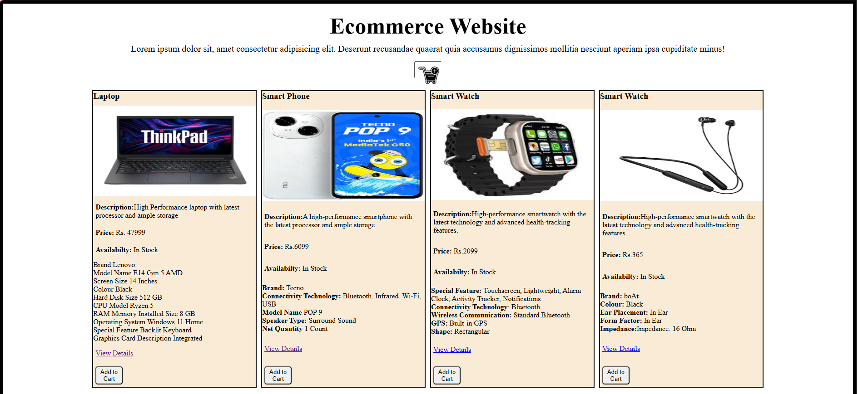

**EXPERIMENT 9**

**DOM**

***Experiment 9.1: Basic DOM implementation***

**Code:**  
<!DOCTYPE html>

<html lang="en">

<head>

    <meta charset="UTF-8">

    <meta name="viewport" content="width=device-width, initial-scale=1.0">

    <title>DOM</title>

    <style>

        .box {

            width: 200px;

            height: 100px;

            background-color: lightgray;

            text-align: center;

            line-height: 100px;

            font-size: 20px;

            margin: 20px;

            transition: all 0.5s ease;

        }

        .hidden {

            display: none;

        }

        .highlight {

            border: 3px dashed red;

            background-color: yellow;

            color: black;

        }

    </style>

</head>

<body>

    <div id="myBox" class="box">Hello</div>

    <button onclick="changeContent()">Change Content</button>

    <button onclick="toggleVisibility()">Toggle Visibility</button>

    <button onclick="createNewElement()">Add New Element</button>

    <script>

        function changeContent() {

            let box = document.getElementById("myBox");

            box.innerHTML = "Text Changed!";

            box.style.color = "white";

            box.style.backgroundColor = "blue";

            box.style.fontSize = "25px";

            box.style.border = "2px solid black";

        }

        function toggleVisibility() {

            let box = document.getElementById("myBox");

            box.classList.toggle("hidden");

        }

        function createNewElement() {

            let newElement = document.createElement("div");

            newElement.innerHTML = "New Element";

            newElement.classList.add("box");

            document.body.appendChild(newElement);

        }

    </script>

</body>

</html>

**Output:**

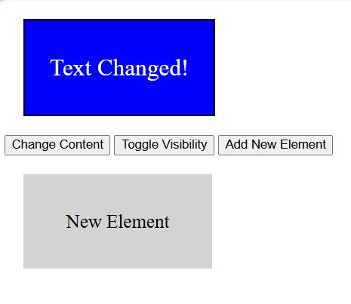

***Experiment 9.2: Live Character Counter***

**Code:**

<textarea id="textArea" maxlength="100"></textarea>

<p>Characters: <span id="charCount">0</span>/100</p>

<script>

const textArea = document.getElementById("textArea");

const charCount = document.getElementById("charCount");

textArea.addEventListener("input", () => {

let count = textArea.value.length;

charCount.textContent = count;

charCount.style.color = count >= 100 ? "red" : "black";

});

</script>

**Output:**

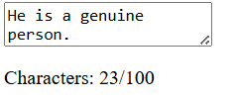

***Experiment 9.3 : Dark Mode Toggle***

**Code:**

<button id="darkModeToggle">Toggle Dark Mode</button>

<script>

const button = document.getElementById("darkModeToggle");

const body = document.body;

button.addEventListener("click", () => {

body.classList.toggle("dark-mode");

localStorage.setItem("darkMode", body.classList.contains("dark-mode"));

});

if (localStorage.getItem("darkMode") === "true") {

body.classList.add("dark-mode");

}

</script>

<style>

.dark-mode {

background-color: black;

color: white; }

</style>

**Output:**

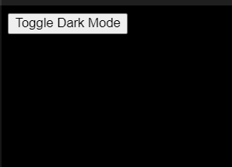

***Experiment 9.4 : Dynamic List Creator***

**Code:**

<input type="text" id="itemInput" placeholder="Enter item">

<button id="addItem">Add Item</button>

<ul id="itemList"></ul>

<script>

const input = document.getElementById("itemInput");

const addButton = document.getElementById("addItem");

const list = document.getElementById("itemList");

addButton.addEventListener("click", () => {

if (input.value.trim() === "") return;

const li = document.createElement("li");

li.textContent = input.value;

const deleteBtn = document.createElement("button");

deleteBtn.textContent = "X";

deleteBtn.style.marginLeft = "10px";

deleteBtn.onclick = () => li.remove();

li.appendChild(deleteBtn);

list.appendChild(li);

input.value = ""; });

</script>

**Output:**

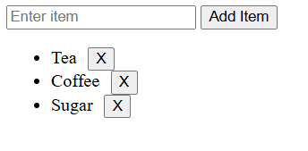

***Experiment 9.5: Image Gallery with Preview***

**Code:**

<img id="preview" src="laptop.jpg" width="300" border="2px solid black">

<div id="thumbnails">

<img src="earphones.png" width="100" border="2px solid black">

<img src="smartphone.jpg" width="100"border="2px solid black">

<img src="watch.jpg" width="100" border="2px solid black">

</div>

<script>

const preview = document.getElementById("preview");

document.getElementById("thumbnails").addEventListener("click", (e) => {

if (e.target.tagName === "IMG") {

preview.src = e.target.src;

}

});

</script>

**Output:**

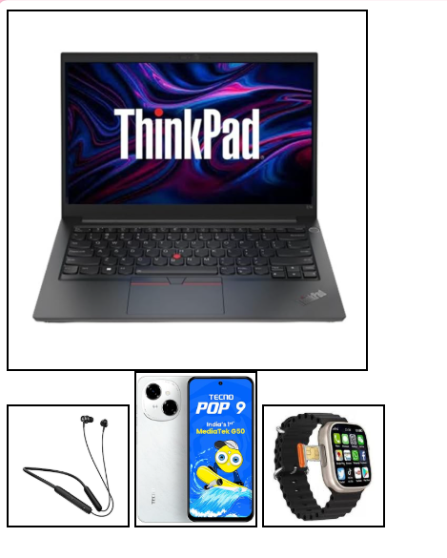

***Experiment 9.6 : Drag and Drop Boxes***

**Code:**

<div id="dragBox" draggable="true">Drag Me</div>

<div id="dropZone">Drop Here</div>

<script>

const dragBox = document.getElementById("dragBox");

const dropZone = document.getElementById("dropZone");

dragBox.addEventListener("dragstart", (e) => {

e.dataTransfer.setData("text", "dragBox");

});

dropZone.addEventListener("dragover", (e) => e.preventDefault());

dropZone.addEventListener("drop", (e) => {

e.preventDefault();

dropZone.appendChild(dragBox);

dropZone.style.backgroundColor = "lightgreen";

});

</script>

<style>

#dragBox {

width: 100px;

height: 100px;

background: blue;

color: white;

text-align: center;

line-height: 100px;

    cursor: grab;

  }

  #dropZone {

    width: 200px;

    height: 200px;

    border: 2px dashed black;

    display: flex;

    align-items: center;

    justify-content: center;

    margin-top: 20px;

  }

</style>

**Output:**

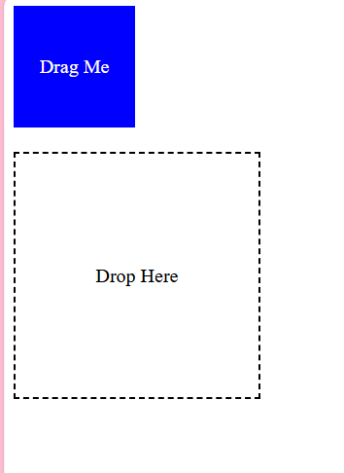 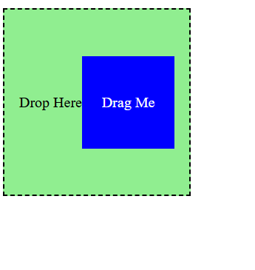

***Experiment 9.7: Custom Context Menu***

**Code:**

<!DOCTYPE html>

<html lang="en">

<head>

  <meta charset="UTF-8">

  <meta name="viewport" content="width=device-width, initial-scale=1.0">

  <title>Custom Context Menu</title>

  <style>

    body {

      font-family: Arial, sans-serif;

      margin: 10px;

      height: 100vh;

      display: flex;

      justify-content: center;

      align-items: center;

      background-color: #f2d2d2;

      flex-wrap: wrap;

    }

    #customMenu {

      position: absolute;

      display: none;

      background: #d5c2c2;

      border: 1px solid #4e4444;

      box-shadow: 0px 4px 6px rgba(0, 0, 0, 0.2);

      z-index: 1000;

    }

    #customMenu ul {

      list-style: none;

      margin: 0;

      padding: 10px 0;

    }

    #customMenu ul li {

      padding: 10px 20px;

      cursor: pointer;

    }

    #customMenu ul li:hover {

      background-color: #d78686;

    }

    img{

        height: 600px;

        width:400px;

        padding: 20px;

        border: 2px solid black;

        margin: 20px;

    }

    h1{

        border: 2px solid #a75c5c;

        padding: 20px;

        margin: auto;

        font-family: 'Times New Roman', Times, serif;

        font-size: 60px;

    }

  </style>

</head>

<body>

    <h1>What would you like to read?</h1>

  <div id="customMenu">

    <ul>

      <li id="option1">A poem</li>

      <li id="option2">A story</li>

      <li id="option3">A quote</li>

    </ul>

  </div>

  <script>

    const customMenu = document.getElementById("customMenu");

    window.addEventListener("contextmenu", (event) => {

      event.preventDefault();

      const { clientX: mouseX, clientY: mouseY } = event;

      customMenu.style.top = `${mouseY}px`;

      customMenu.style.left = `${mouseX}px`;

      customMenu.style.display = "block";

    });

    window.addEventListener("click", () => {

      customMenu.style.display = "none";

    });

    document.getElementById("option1").addEventListener("click", () => {

        const img = document.createElement("img");

        img.src = "poem.jpeg";

        img.alt = "Displayed Image";

        document.body.appendChild(img);

    });

    document.getElementById("option2").addEventListener("click", () => {

        const img = document.createElement("img");

        img.src = "story.jpg";

        img.alt = "Displayed Image";

        document.body.appendChild(img);

    });

    document.getElementById("option3").addEventListener("click", () => {

        const img = document.createElement("img");

        img.src = "quote.jpeg";

        img.alt = "Displayed Image";

        document.body.appendChild(img);

    });

  </script>

</body>

</html>

**Output:**

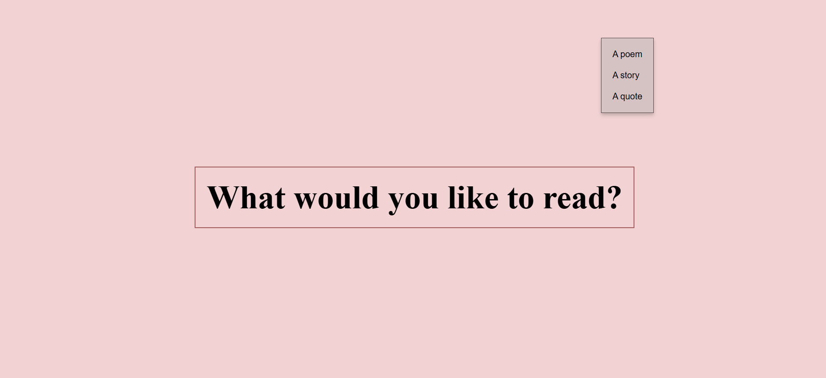

**EXPERIMENT 10**

**Basic Python Programs**

***Experiment 10.1: WAP to print Area Of Circle, Square, Rectangle***

**Code:**

def area_circle():

    r=float(input("Enter radius of the circel: "))

    a=3.14*r*r

    print("The area of circle is: ", a)

def area_rectangle():

    l=int(input("Enter length of rectangle: "))

    b=int(input("Enter breadth of rectangle: "))

    a=l*b

    print("The area of rectangle: ", a)

def area_square():

    s= int(input("Enter side of the square: "))

    a=s*s

    print("The area of square is: ", a)

choice =input("Choose calulate area for: circle/rectangle/square:  ").lower()

if choice=="circle":

    area_circle()

elif choice=="rectangle":

     area_rectangle()

elif choice=="square":

    area_square()

else:

    print("Invalid choice")

**Output:**

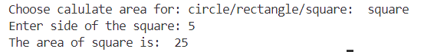

***Experiment 10.2: WAP in python to create a calculator***

**Code:**

def calculator():

    num1=float(input("Enter first number: "))

    num2=float(input("Enter second number: "))

    operator=input("Enter operator: ")

    if operator=='+':

        print("Result: ", num1+num2)

    elif operator=='-':

        print("Result: ", num1-num2)

    elif operator=='*':

        print("Result: ", num1*num2)

    elif operator=='/':

        if num2!=0:

            print("Result: ", num1/num2)

        else:

            print("Cannot divide by zero")

    else:

        print("Invalid operator")

calculator()

**Output:**

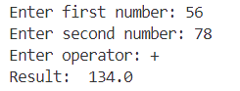

***Experiment 10.3: WAP to print Fibonacci Series***

**Code:**

def fibonacci(n):

    if n <= 0:

        return []

    elif n == 1:

        return [0]

    elif n == 2:

        return [0, 1]

    series = fibonacci(n - 1)

    series.append(series[-1] + series[-2])

    return series

num = int(input("Enter the number of terms: "))

print("Fibonacci Series:", fibonacci(num))

**Output:**

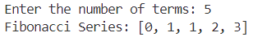

***Experiment 10.4: WAP to check if input string is palindrome or not***

**Code:**

def is_palindrome(s):

    reversed_s = s[::-1]

    print(f"Reversed String: {reversed_s}")

    if s == reversed_s:

        print("The string is a palindrome.")

    else:

        print("The string is not a palindrome.")

string = input("Enter a string: ").lower()

is_palindrome(string)

**Output:**

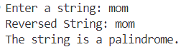

***Experiment 10.5: WAP to print following patterns***

1. ***\****

***\* \****

***\* * \****

***\* * * \****

**Code:**

n=4

for i in range(1, n + 1):

    for j in range(1, i + 1):

        print('*', end=" ")

    print()

**Output:**

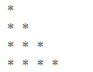

1. ***1***

***1 2***

***1 2 3***

***1 2 3 4***

**Code:**

n = 4

for i in range(1, n + 1):

    for j in range(1, i + 1):

        print(j, end=" ")

    print()

**Output:**

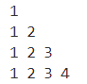

***Experiment 10.6: WAP to create a To-Do List***

**Code:**

tasks=[]

def add_task(task):

    tasks.append(task)

def remove_task(task):

    if task in tasks:

        tasks.remove(task)

def show_tasks():

    print("To-DO-LIST")

    for i, task in enumerate(tasks, start=1):

        print(f"{i}.{task}")

while True:

    choice =input("Choose: add/remove/show/quit: ").lower()

    if choice=="add":

        task=input("Enter a task: ")

        add_task(task)

    elif choice=="remove":

         task = input("Enter task to remove: ")

         remove_task(task)

    elif choice=="show":

        show_tasks()

    elif choice=="quit":

        break

    else:

        print("Invalid choice")

**Output:**

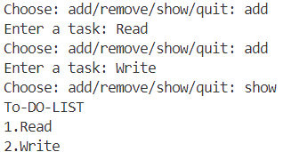

***Experiment 10.7: Conditional Statements***

**Code:**

num = int(input("Enter a number: "))

if num > 0:

    print("Positive number")

elif num < 0:

    print("Negative number")

else:

    print("Zero")

**Output:**

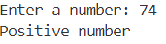

***Experiment 10.8: Loops***

**For Loop**

**Code:**

for i in range(5):

    print(i)

**Output:**

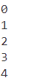

**While Loop**

**Code:**

count = 0

while count < 5:

    print(count)

    count += 1

**Output:**



***Experiment 10.9: WAP to print characters of a string***

**Code:**

s=input("Enter a string: ")

for i in range(len(s)):

    print (s[i])

**Output:**

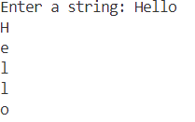

***Experiment 10.10: WAP to print sum of digits of a number entered by the user***

**Code:**

n=int(input("Enter a number: "))

sum=0

while(n>0):

    d=n%10

    sum+=d

    n=n//10

print("The sum of number is: ", sum)

**Output:**

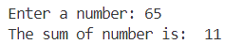

***Experiment 10.11: WAP to convert temperature in Fahrenheit to Celsius and Celsius to Fahrenheit***

**Code:**

tempF=int(input("Enter temperature in Fahrenheit: "))

tempC=(5/9)*(tempF-32)

print("The temperature in Celsius is: ", tempC)

tempC2=int(input("Enter temperature in Celsius: "))

tempF2=(9/5)*(tempC2)+32

print("The temperature in Fahrenheit is: ", tempF2)

**Output:**

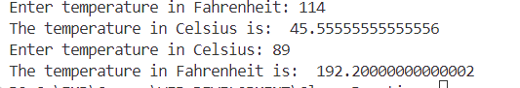

***Experiment 10.12: WAP to check if input string is palindrome or not***

**Code:**

def is_palindrome(s):

    reversed_s = s[::-1]

    print(f"Reversed String: {reversed_s}")

    if s == reversed_s:

        print("The string is a palindrome.")

    else:

        print("The string is not a palindrome.")

string = input("Enter a string: ").lower()

is_palindrome(string)

**Output:**



***Experiment 10.13: WAP to count characters of a string***

**Code:**

for i in range(len(s)):

    if(s[i].isalpha()):

        sum+=1

print("The number of characters in given string is: ", sum)

**Output:**



**EXPERIMENT 11**

**Basic Flask Programs**

***Experiment 11.1: Basic "Hello, World!" Flask App***

**Code:**

from flask import Flask

app = Flask(__name__)@app.route('/')

def hello_world():

return "Hello, World! Welcome to Flask."

if __name__ == '__main__':

app.run(debug=True)

**Output:**

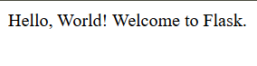

***Experiment 11.2: Flask App with Dynamic Routes***

**Code:**

from flask import Flask

app = Flask(__name__)

@app.route('/user/<username>')

def show_user_profile(username):

return f"Hello, {username}! Welcome to your profile."

@app.route('/square/<int:number>')

def square_number(number):

return f"The square of {number} is {number**2}"

if __name__ == '__main__':

app.run(debug=True)

**Output:**

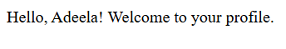

***Experiment 11.3: Flask App with HTML Templates (Jinja2)***

**Code:**

**HTML Template (templates/home.html):**

<!DOCTYPE html>

<html lang="en">

<head>

<title>{{ title }}</title>

</head>

<body>

<h1>Welcome to {{ title }}!</h1>

<p>This is a dynamic page rendered using Flask and Jinja2.</p>

</body>

</html>

**Python Code (app.py):**

from flask import Flask, render_template

app = Flask(__name__)

@app.route('/')

def home():

return render_template('home.html', title="Flask Template Example")

if __name__ == '__main__':

app.run(debug=True)

**Output:**

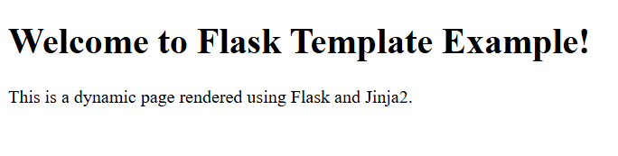

***Experiment 11.4: Flask App with Forms***

**Code:**

**HTML Form (templates/form.html):**

<!DOCTYPE html>

<html lang="en">

<head>

<title>Flask Form Example</title>

</head>

<body>

<h2>Enter your name:</h2>

<form action="/greet" method="post">

<input type="text" name="name" required>

<input type="submit" value="Submit">

</form>

</body>

</html>

**Python Code (app.py):**

from flask import Flask, request, render_template

app = Flask(__name__)

@app.route('/')

def form():

return render_template('form.html')

@app.route('/greet', methods=['POST'])

def greet():

name = request.form['name']

return f"Hello, {name}! Welcome to Flask."

if __name__ == '__main__':

app.run(debug=True)

**Output:**

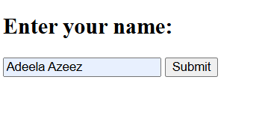

**EXPERIMENT 12**

**Flask programs that render HTML pages using different techniques**

***Experiment 12.1: Basic HTML Rendering***

from flask import Flask, render_template_string

app = Flask(__name__)

@app.route('/')

def home():

html = """

<html>

<head><title>Home</title></head>

<body>

<h1>Welcome to Flask</h1>

<p>This is a basic HTML page.</p>

</body>

</html>

"""

return render_template_string(html)

if __name__ == '__main__':

app.run(debug=True)

**Output:**

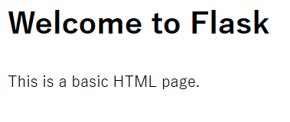

***Experiment 12.2: Rendering HTML from a Template File***

**app.py**

from flask import Flask, render_template

app = Flask(__name__)

@app.route('/')

def home():

return render_template("index.html")

if __name__ == '__main__':

app.run(debug=True)

**templates/index.html**

<!DOCTYPE html>

<html>

<head>

<title>Flask Template</title>

</head>

<body>

<h1>Welcome to Flask!</h1>

<p>This is a page rendered from an HTML template.</p>

</body>

</html>

**Output:**

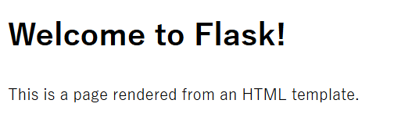

***Experiment 12.3: Passing Data to HTML Template***

**app.py**

from flask import Flask, render_template

app = Flask(__name__)

@app.route('/')

def home():

user = "John Doe"

return render_template("welcome.html", username=user)

if __name__ == '__main__':

app.run(debug=True)

**templates/welcome.html**

<!DOCTYPE html>

<html>

<head>

<title>Flask Variables</title>

</head>

<body>

<h1>Hello, {{ username }}!</h1>

<p>Welcome to your personalized Flask page.</p>

</body>

</html>

**Output:**

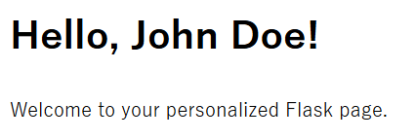

***Experiment 12.4: Rendering a List in an HTML Template***

**app.py**

from flask import Flask, render_template

app = Flask(__name__)

@app.route('/')

def home():

items = ["Apple", "Banana", "Cherry", "Date"]

return render_template("list.html", items=items)

if __name__ == '__main__':

app.run(debug=True)

**templates/list.html**

<!DOCTYPE html>

<html>

<head>

<title>Flask List</title>

</head>

<body>

<h1>Fruit List</h1>

<ul>

{% for item in items %}

<li>{{ item }}</li>

{% endfor %}

</ul>

</body>

</html>

**Output:**

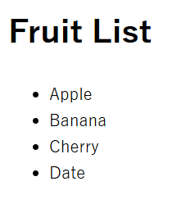

***Experiment 12.5: Rendering a Form and Processing Input***

**app.py**

from flask import Flask, render_template, request

app = Flask(__name__)

@app.route('/', methods=['GET', 'POST'])

def form():

if request.method == 'POST':

name = request.form['name']

return render_template("greeting.html", name=name)

return render_template("form.html")

if __name__ == '__main__':

app.run(debug=True)

**templates/form.html**

<!DOCTYPE html>

<html>

<head>

<title>Flask Form</title>

</head>

<body>

<h1>Enter Your Name</h1>

<form method="post">

<input type="text" name="name" required>

<input type="submit" value="Submit">

</form>

</body>

</html>

**templates/greeting.html**

<!DOCTYPE html>

<html>

<head>

<title>Greeting</title>

</head>

<body>

<h1>Hello, {{ name }}!</h1>

<p>Welcome to Flask!</p>

</body>

</html>

**Output:**

